Name : Tamanna
Ht.no : 2303A51859
Batch 24

Lab 11 – Data Structures with AI: Implementing Fundamental Structures
Lab Objectives
• Use AI to assist in designing and implementing fundamental data structures in Python.
• Learn how to prompt AI for structure creation, optimization, and documentation.
• Improve understanding of Lists, Stacks, Queues, Linked Lists, Trees, Graphs, and Hash Tables.
• Enhance code quality with AI-generated comments and performance suggestions.
Task Description #1 – Stack Implementation
Task: Use AI to generate a Stack class with push, pop, peek, and is_empty methods.
Sample Input Code:
class Stack:
pass
Expected Output:
• A functional stack implementation with all required methods and docstrings.
Code:
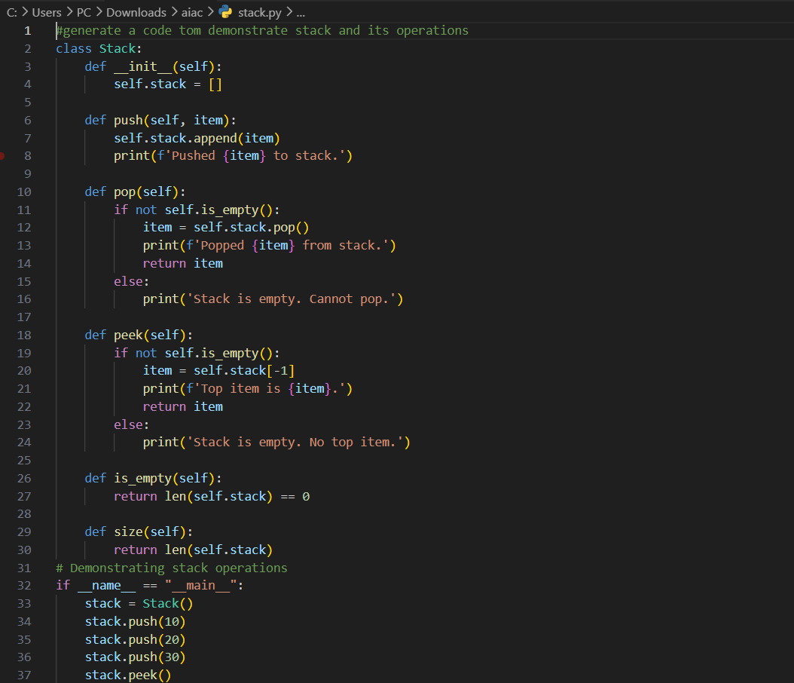
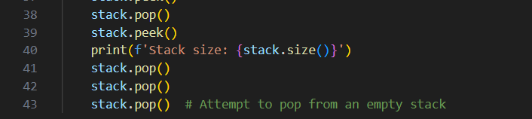
Output:
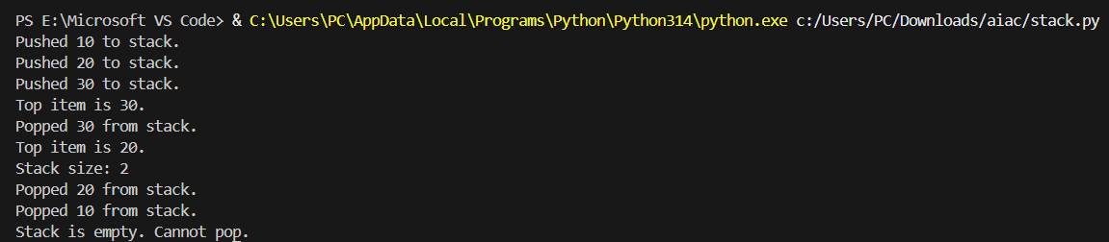

Task Description #2 – Queue Implementation
Task: Use AI to implement a Queue using Python lists.
Sample Input Code:
class Queue:
pass
Expected Output:
• FIFO-based queue class with enqueue, dequeue, peek, and size methods.

Code:
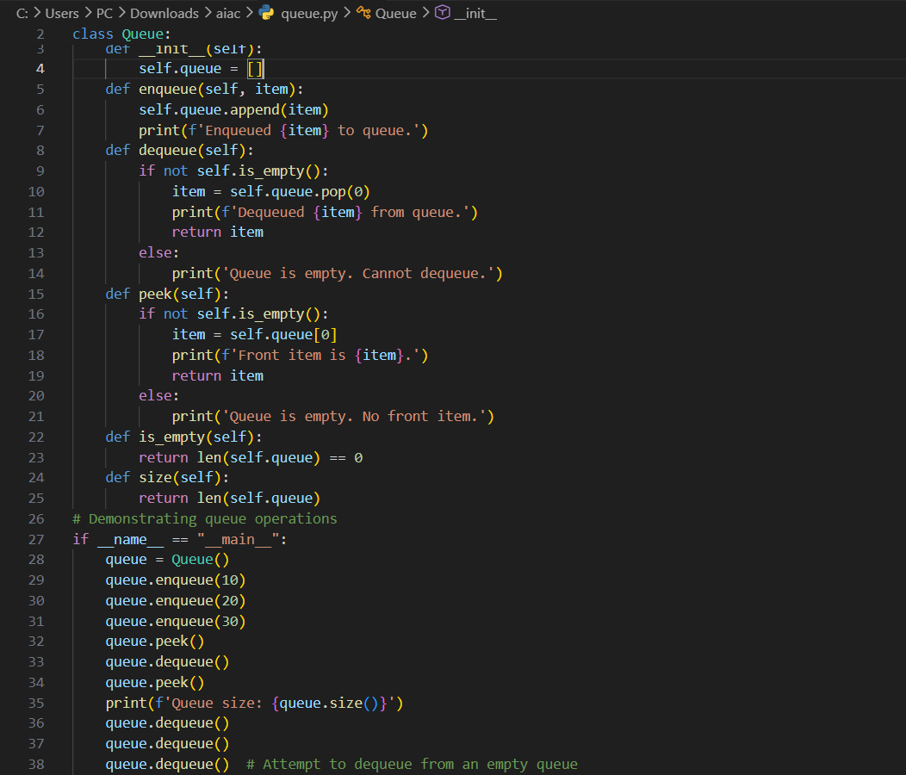
Output:
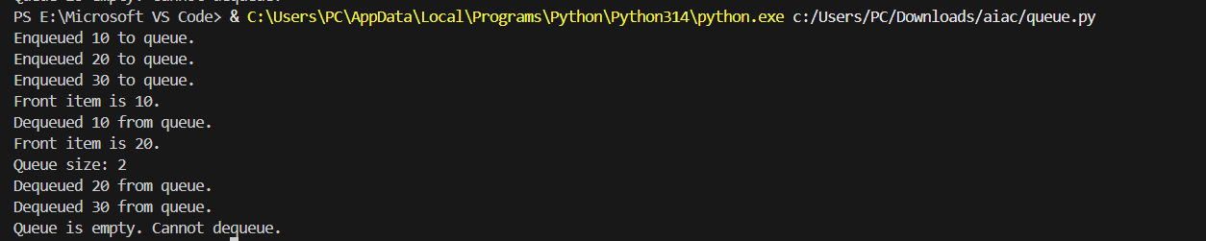

Task Description #3 – Linked List
Task: Use AI to generate a Singly Linked List with insert and display methods.
Sample Input Code:
class Node:
pass
class LinkedList:
pass
Expected Output:
• A working linked list implementation with clear method documentation.
Code:
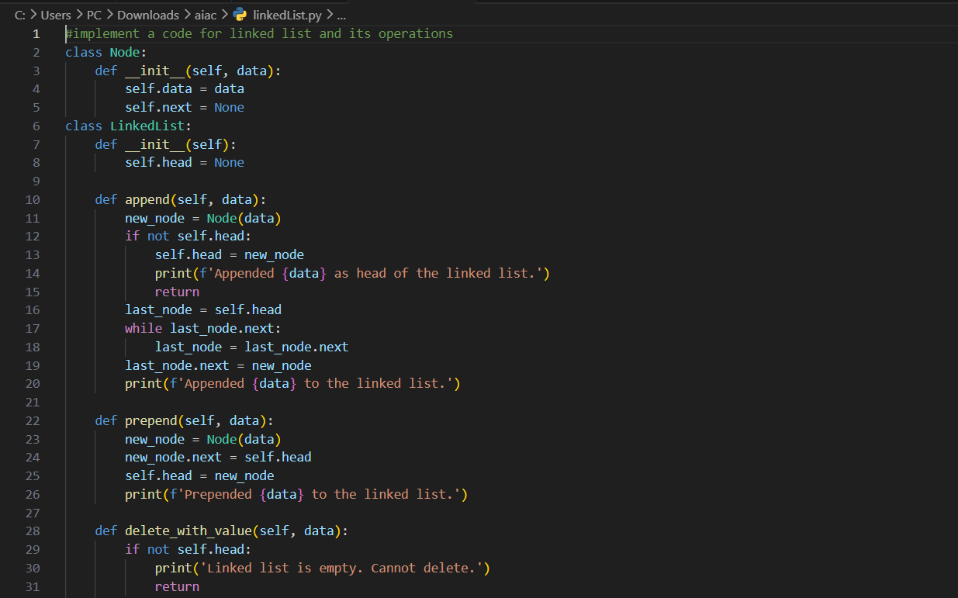
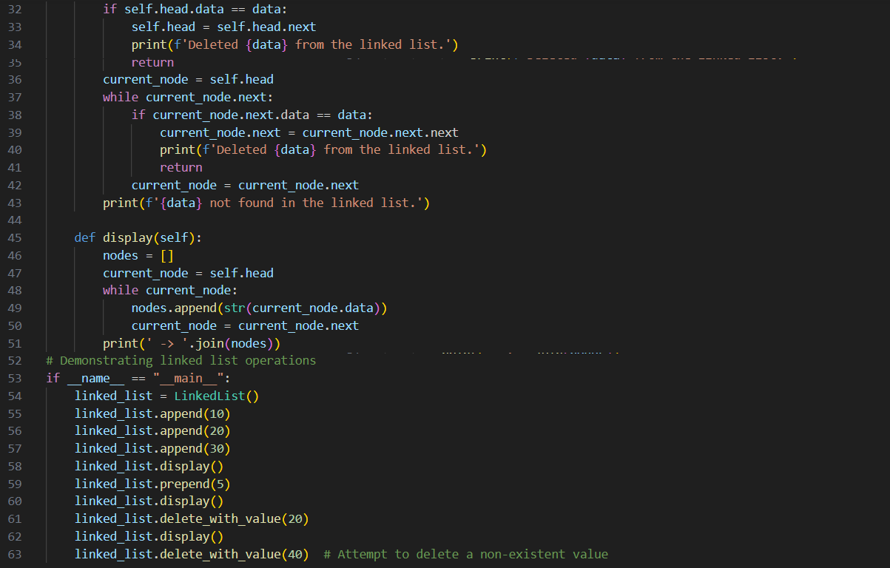
Output:

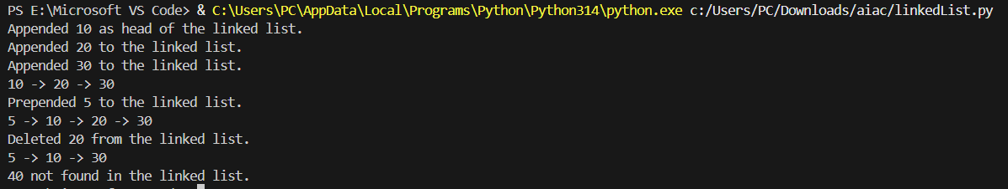

Task Description #4 – Binary Search Tree (BST)
Task: Use AI to create a BST with insert and in-order traversal methods.
Sample Input Code:
class BST:
pass
Expected Output:
• BST implementation with recursive insert and traversal methods.
Code:
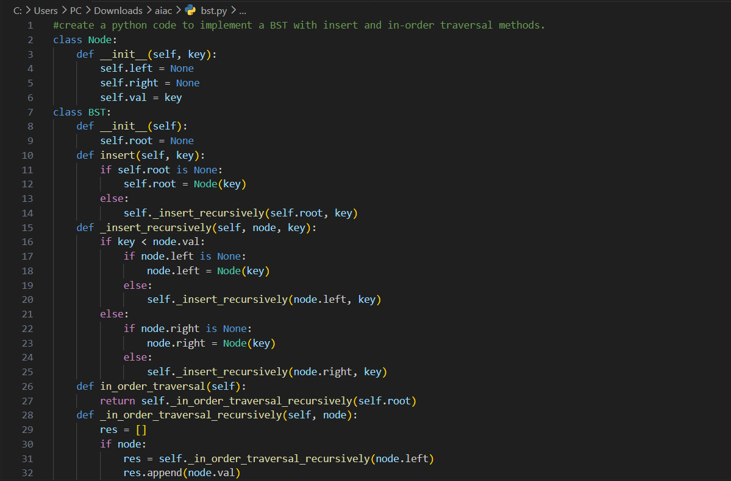
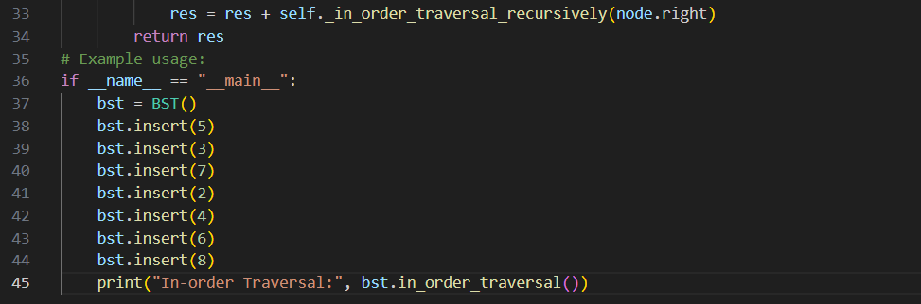
Output:
Task Description #5 – Hash Table
Task: Use AI to implement a hash table with basic insert, search, and delete methods.
Sample Input Code:
class HashTable:
pass
Expected Output:
• Collision handling using chaining, with well-commented methods.
Code:
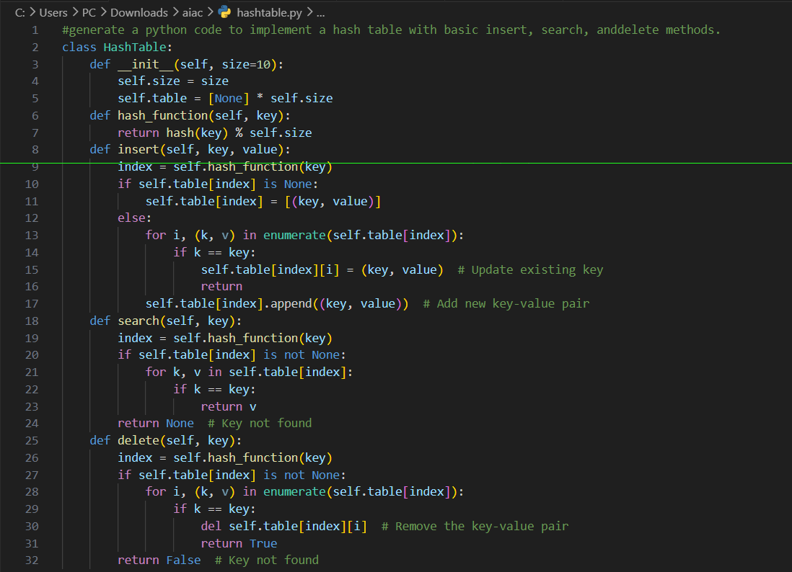
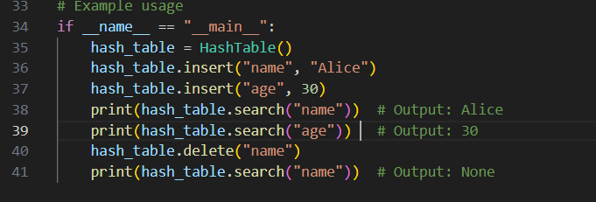
Output:
Task Description #6 – Graph Representation
Task: Use AI to implement a graph using an adjacency list.
Sample Input Code:
class Graph:
pass
Expected Output:
• Graph with methods to add vertices, add edges, and display connections.
Code:
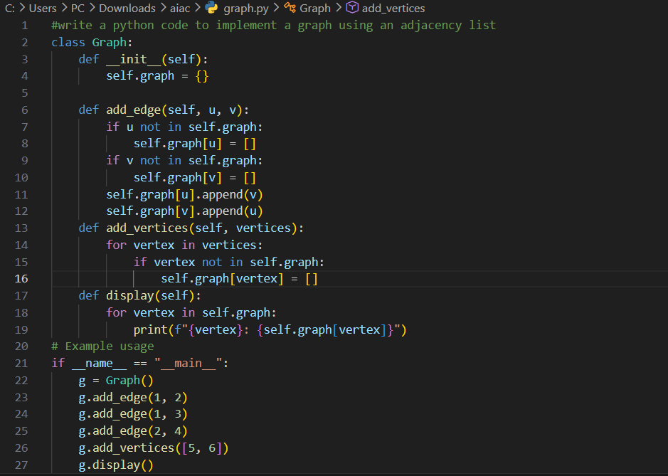
Output:
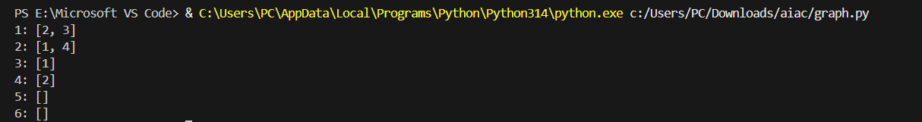
Task Description #7 – Priority Queue
Task: Use AI to implement a priority queue using Python’s heapq module.
Sample Input Code:
class PriorityQueue:
pass
Expected Output:
• Implementation with enqueue (priority), dequeue (highest priority), and display methods.
Code:
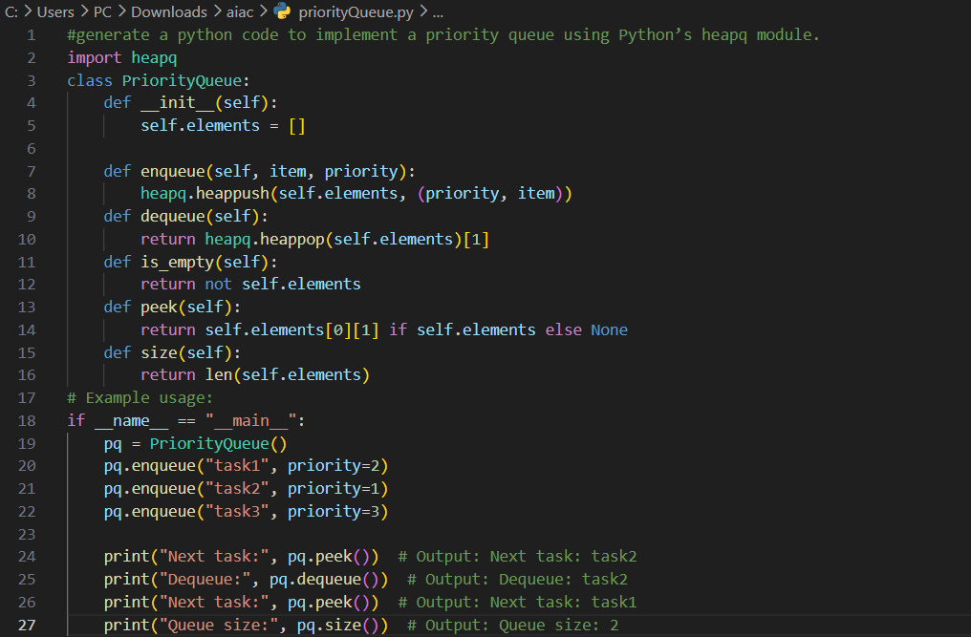
Output:
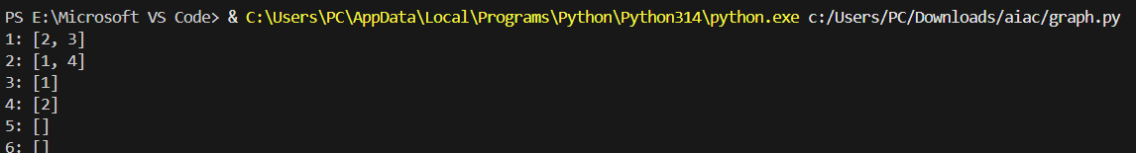

Task Description #8 – Deque
Task: Use AI to implement a double-ended queue using collections.deque.
Sample Input Code:
class DequeDS:
pass
Expected Output:
• Insert and remove from both ends with docstrings.
Code:
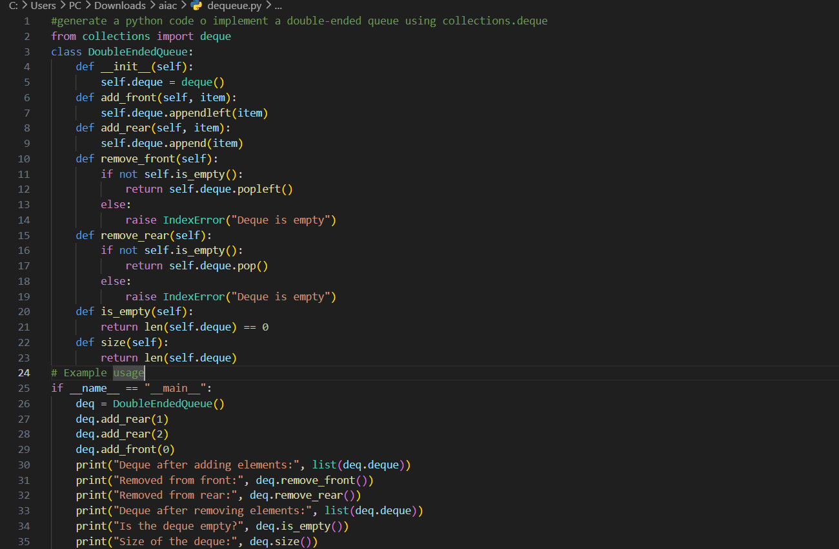
Output:
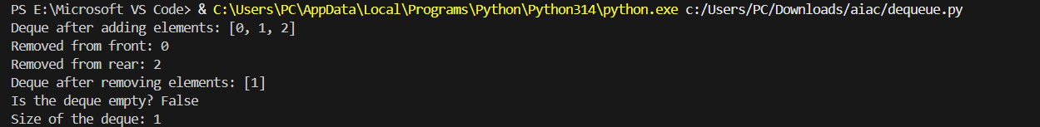
Task Description #9 Real-Time Application Challenge – Choose theRight Data Structure
Scenario:
Your college wants to develop a Campus Resource Management System
that handles:
1. Student Attendance Tracking – Daily log of students entering/exiting the campus.
2. Event Registration System – Manage participants in events with quick search and removal.
3. Library Book Borrowing – Keep track of available books and their due dates.
4. Bus Scheduling System – Maintain bus routes and stop connections.
5. Cafeteria Order Queue – Serve students in the order they arrive.
Student Task:
• For each feature, select the most appropriate data structure from the list below:
o Stack
o Queue
o Priority Queue
o Linked List
o Binary Search Tree (BST)
o Graph
o Hash Table
o Deque
• Justify your choice in 2–3 sentences per feature.
• Implement one selected feature as a working Python program with AI-assisted code generation.
Expected Output:
• A table mapping feature → chosen data structure → justification.
• A functional Python program implementing the chosen feature with comments and docstrings
Feature | Data Structure
1. Attendance Tracking | Hash Table
2. Event Registration | Binary Search Tree (BST)
3. Library Borrowing | Linked List
4. Bus Scheduling | Graph
5. Cafeteria Queue | Queue

Code 1:
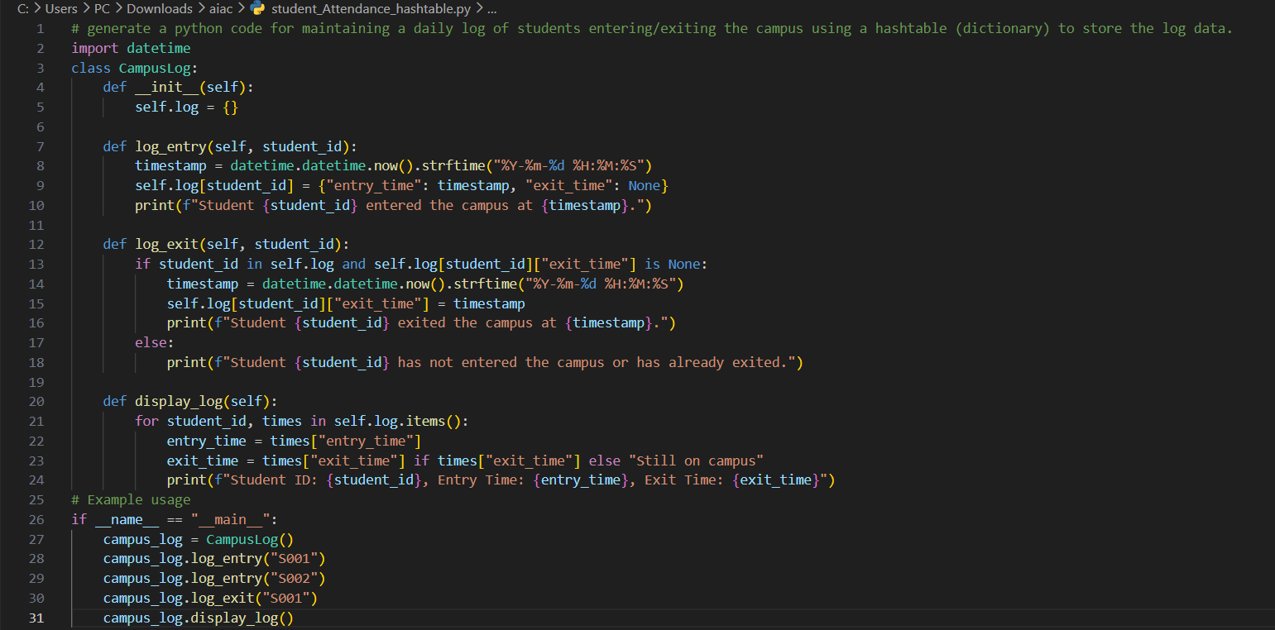
Output 2:
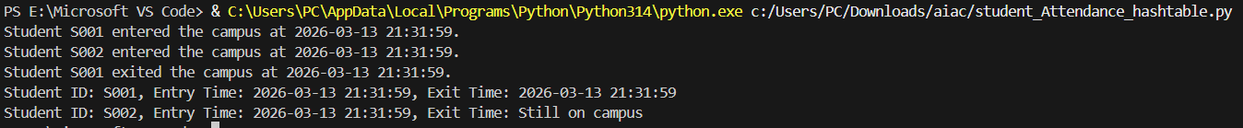

Code 2:
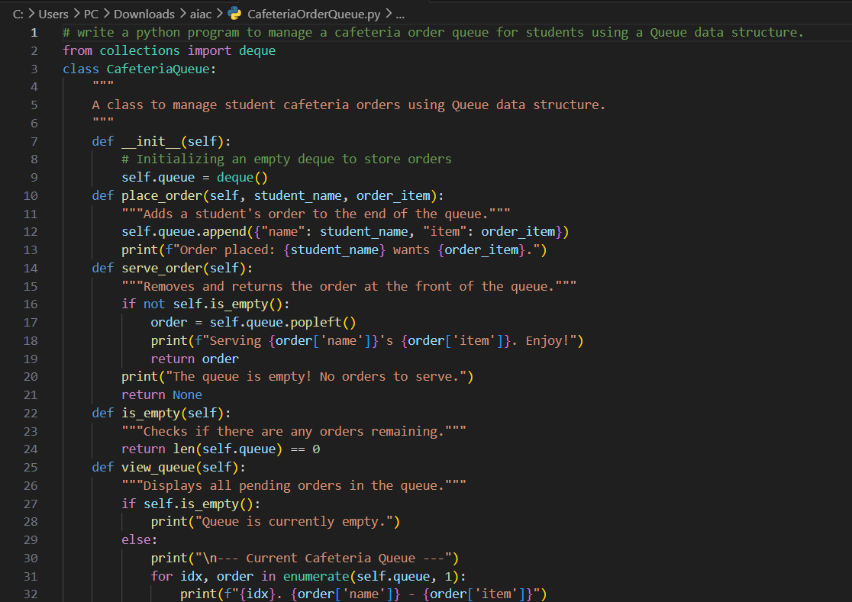
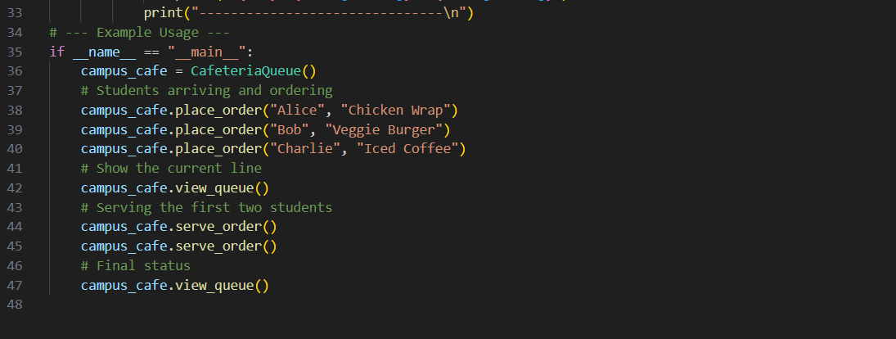
Output 2:
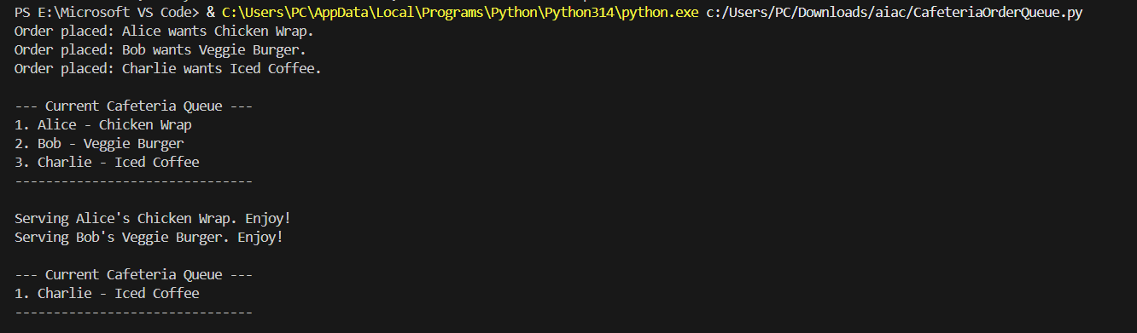

Task Description #10: Smart Hospital Management System – Data Structure Selection
A hospital wants to develop a Smart Hospital Management System that handles:
1. Patient Check-In System – Patients are registered and treated in order of arrival.
2. Emergency Case Handling – Critical patients must be treated first.
3. Medical Records Storage – Fast retrieval of patient details using ID.
4. Doctor Appointment Scheduling – Appointments sorted by time.
5. Hospital Room Navigation – Represent connections between wards and rooms.
Student Task
• For each feature, select the most appropriate data structure from the list below:
o Stack
o Queue
o Priority Queue
o Linked List
o Binary Search Tree (BST)
o Graph
o Hash Table
o Deque
• Justify your choice in 2–3 sentences per feature.
• Implement one selected feature as a working Python program with AI-assisted code generation.
Expected Output:
• A table mapping feature → chosen data structure → justification.
• A functional Python program implementing the chosen feature with comments and docstrings.
Feature | Data Structure
1. Patient Check-In | Queue
2. Emergency Handling | Priority Queue
3. Medical Records | Hash Table
4. Appointment Scheduling | Binary Search Tree (BST)
5. Room Navigation | Graph

Code 1:
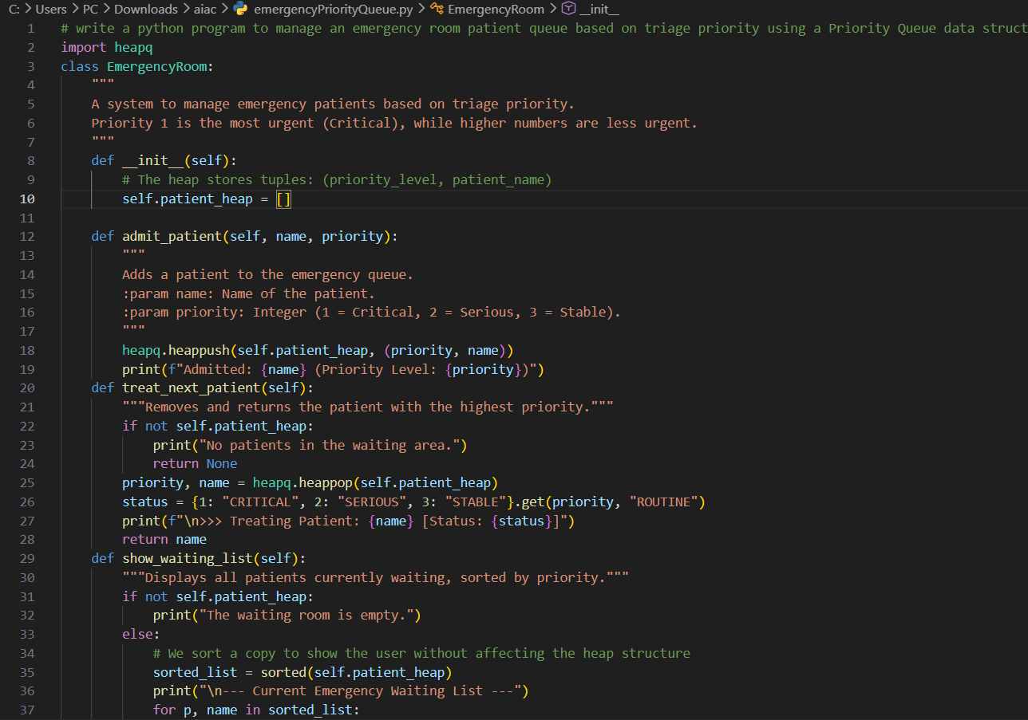
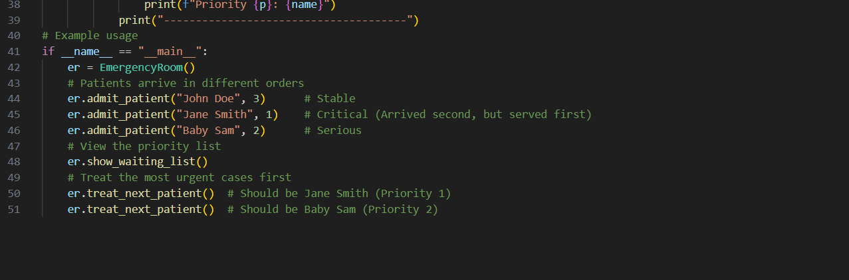

Output 1:
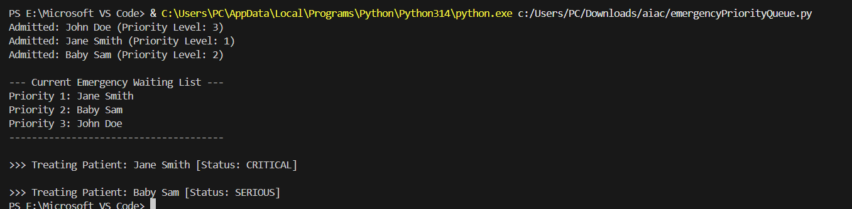
Code 2:
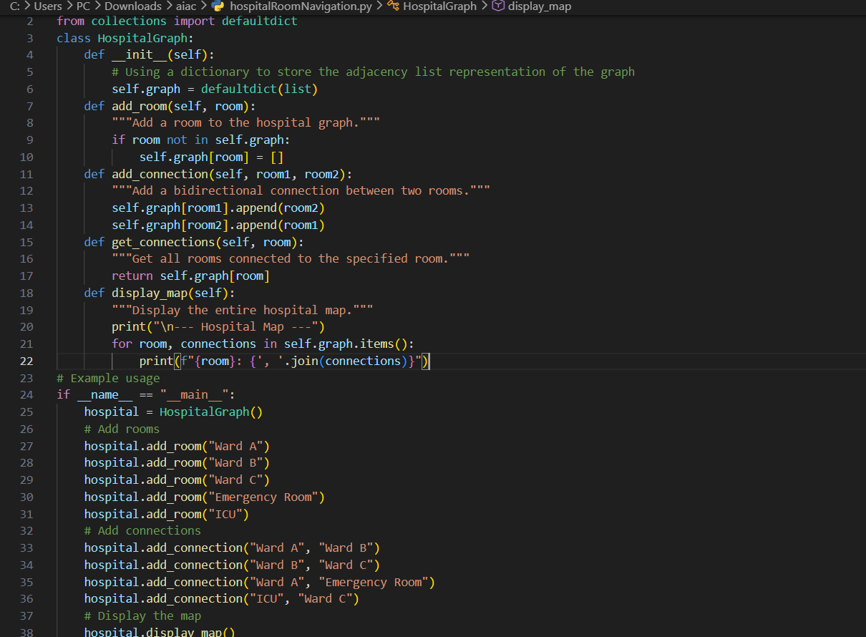
Output 2:
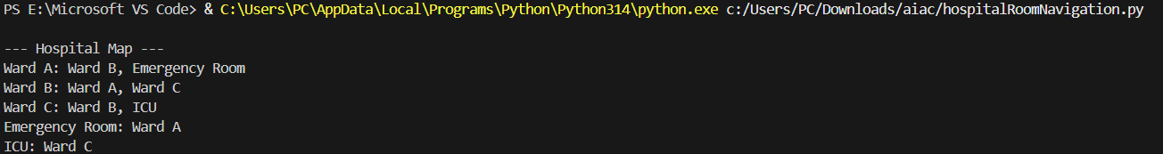
Task Description #11: Smart City Traffic Control System
A city plans a Smart Traffic Management System that includes:
1. Traffic Signal Queue – Vehicles waiting at signals.
2. Emergency Vehicle Priority Handling – Ambulances and fire trucks prioritized.
3. Vehicle Registration Lookup – Instant access to vehicle details.
4. Road Network Mapping – Roads and intersections connected logically.
5. Parking Slot Availability – Track available and occupied slots.
Student Task
• For each feature, select the most appropriate data structure from the list below:
o Stack
o Queue
o Priority Queue
o Linked List
o Binary Search Tree (BST)
o Graph
o Hash Table
o Deque
• Justify your choice in 2–3 sentences per feature.
• Implement one selected feature as a working Python program with AI-assisted code generation.
Expected Output:
• A table mapping feature → chosen data structure → justification.
• A functional Python program implementing the chosen feature with comments and docstrings.

Feature | Data Structure
1. Traffic Signal Queue | Queue
2. Emergency Priority | Priority Queue
3. Vehicle Lookup | Hash Table
4. Road Network Mapping | Graph
5. Parking Availability | Hash Table

Code 1:
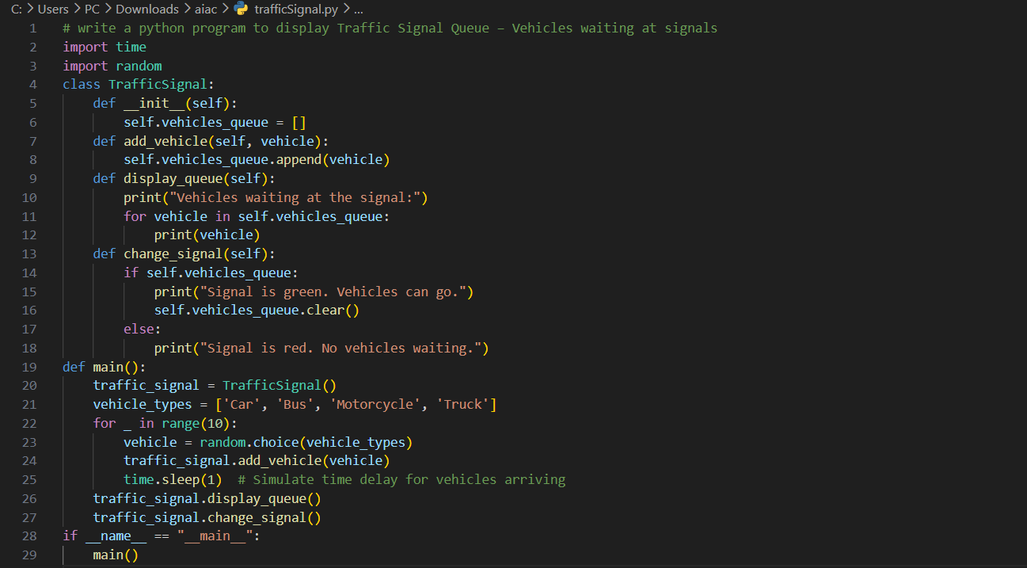
Output 1:
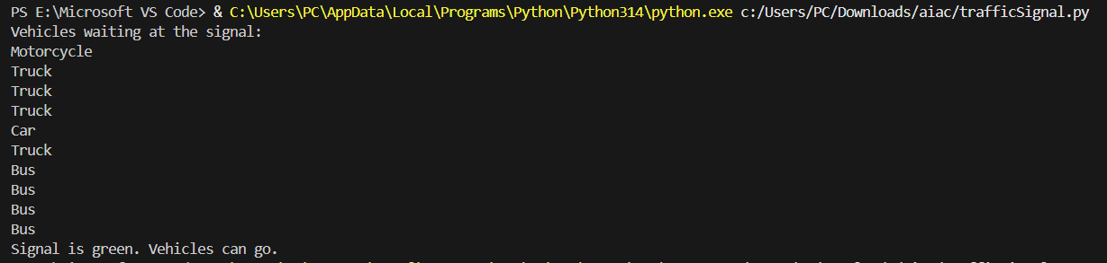
Code 2:
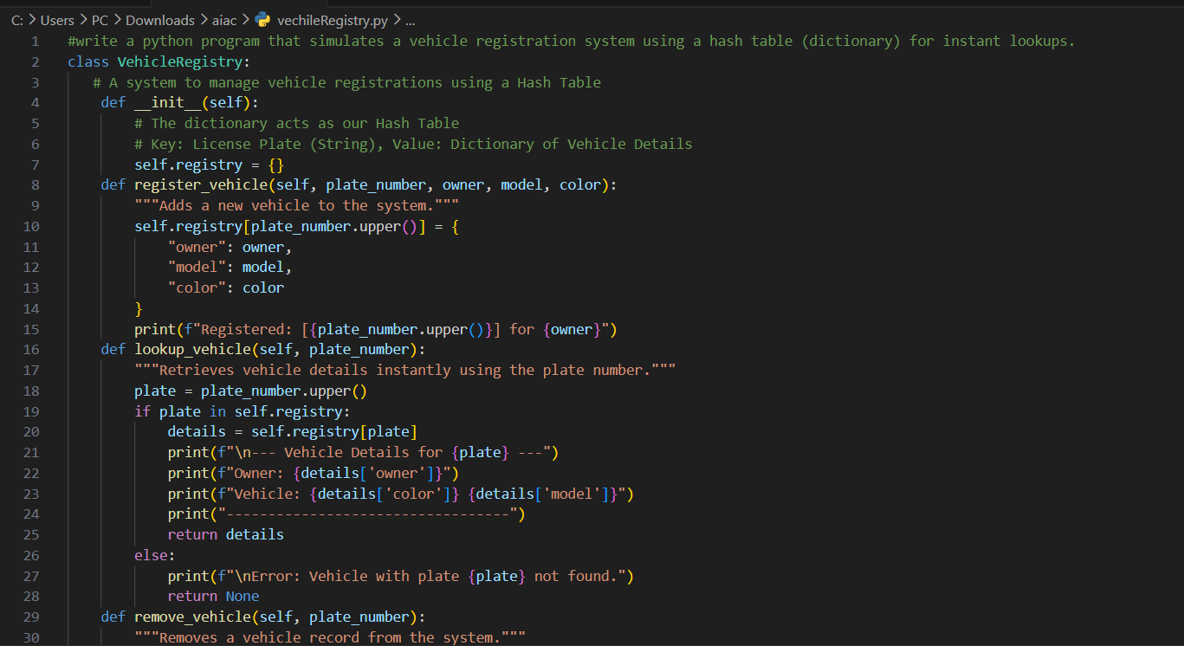
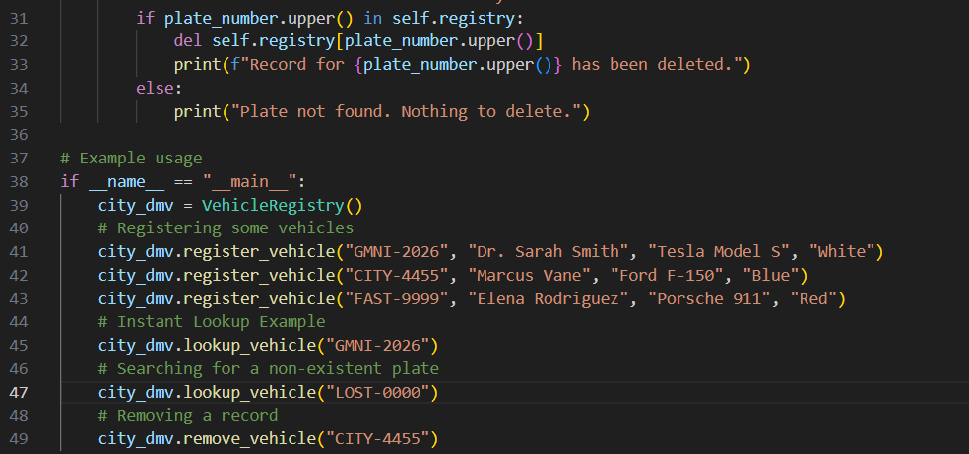
Output 2:
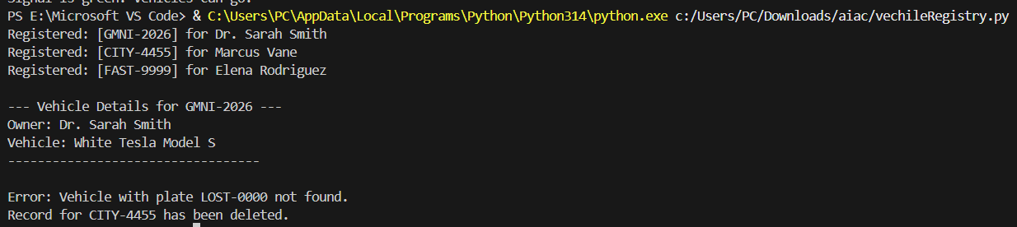

Task Description #12: Smart E-Commerce Platform – Data Structure Challenge
An e-commerce company wants to build a Smart Online Shopping System with:
1. Shopping Cart Management – Add and remove products dynamically.
2. Order Processing System – Orders processed in the order they are placed.
3. Top-Selling Products Tracker – Products ranked by sales count.
4. Product Search Engine – Fast lookup of products using product ID.
5. Delivery Route Planning – Connect warehouses and delivery locations.
Student Task
• For each feature, select the most appropriate data structure from the list below:
o Stack
o Queue
o Priority Queue
o Linked List
o Binary Search Tree (BST)
o Graph
o Hash Table
o Deque
• Justify your choice in 2–3 sentences per feature.
• Implement one selected feature as a working Python program with AI-assisted code generation.
Expected Output:
• A table mapping feature → chosen data structure → justification.
• A functional Python program implementing the chosen feature with comments and docstrings.
Feature | Data Structure
1. Shopping Cart | Linked List
2. Order Processing | Queue
3. Top-Selling Tracker | Priority Queue
4. Product Search | Hash Table
5. Delivery Routes | Graph

Code 1:
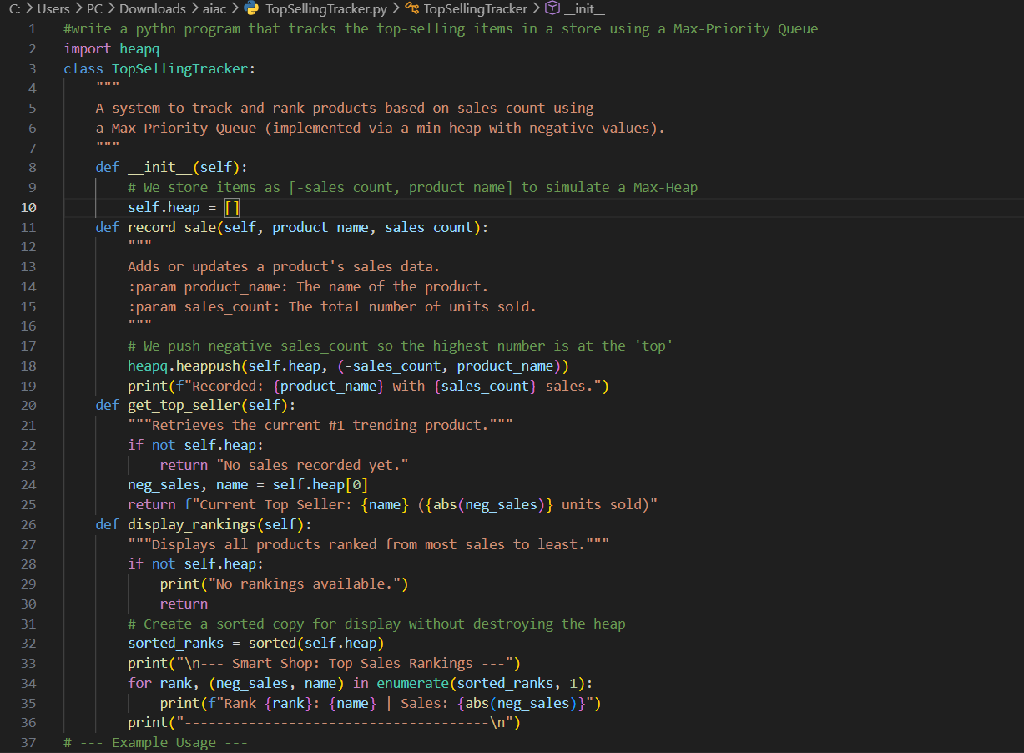
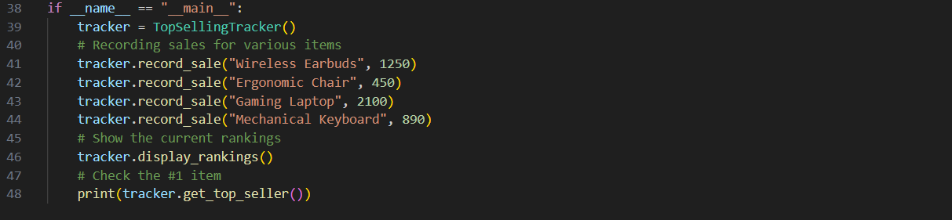
Output 1:
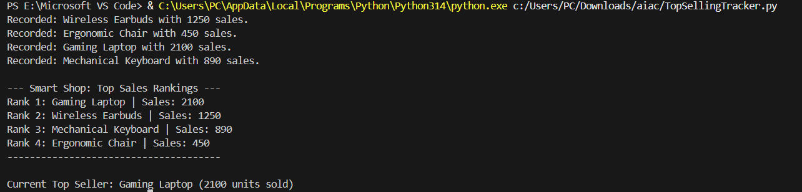

Code 2:
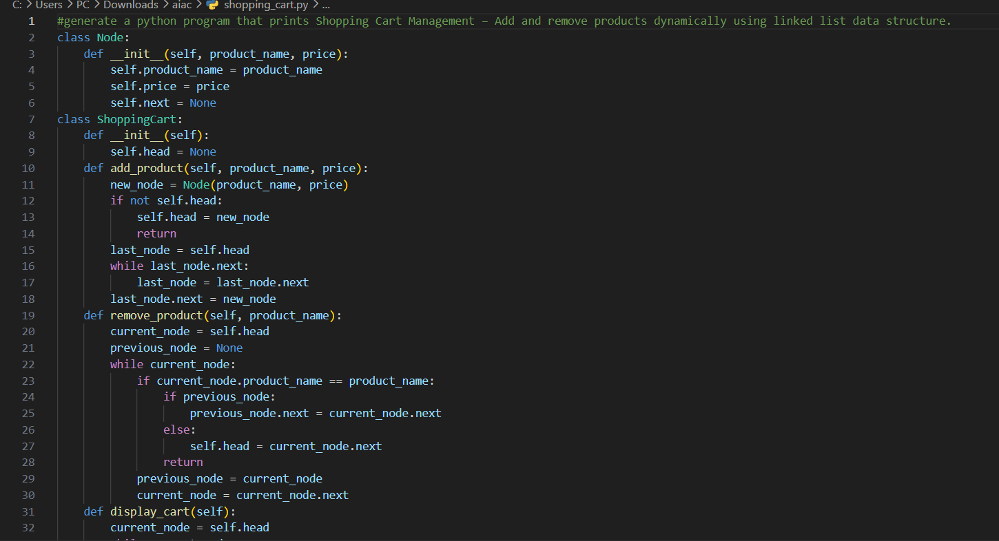
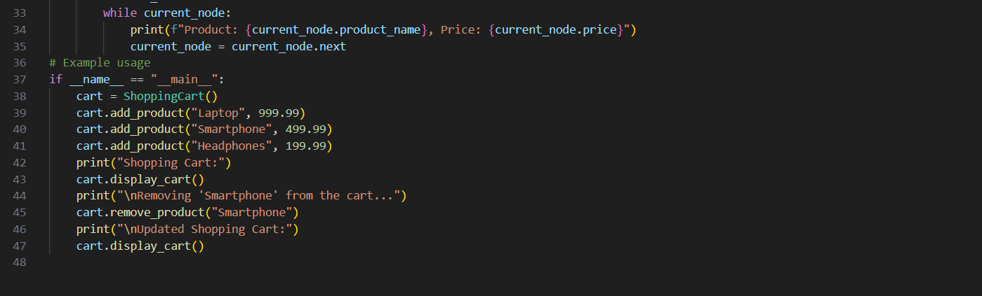
Output 2:
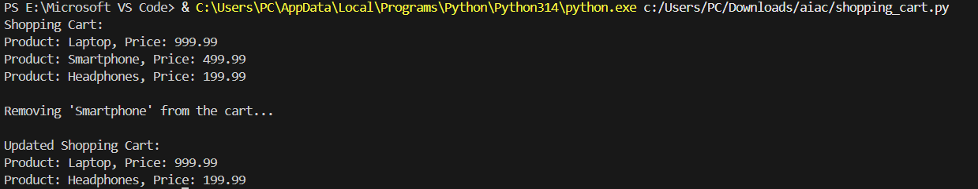
Task #13: Smart Logistics & Warehouse Management
Scenario:
A logistics company wants to implement:
1. Shipment Processing
2. Urgent Shipment Priority
3. Product Lookup by Code
4. Warehouse Network Connectivity
5. Inventory Add/Remove Operations Student Task
• For each feature, select the most appropriate data structure from the list below:
o Stack
o Queue
o Priority Queue
o Linked List
o Binary Search Tree (BST)
o Graph
o Hash Table
o Deque
• Justify your choice in 2–3 sentences per feature.
• Implement one selected feature as a working Python program with AI-assisted code generation.
Expected Output:
• A table mapping feature → chosen data structure → justification.
• A functional Python program implementing the chosen feature with comments and docstrings.
Feature | Data Structure
1. Shipment Processing | Queue
2. Urgent Shipments | Priority Queue
3. Product Lookup | Hash Table
4. Warehouse Network | Graph
5. Inventory Operations | Linked List
Code 1:
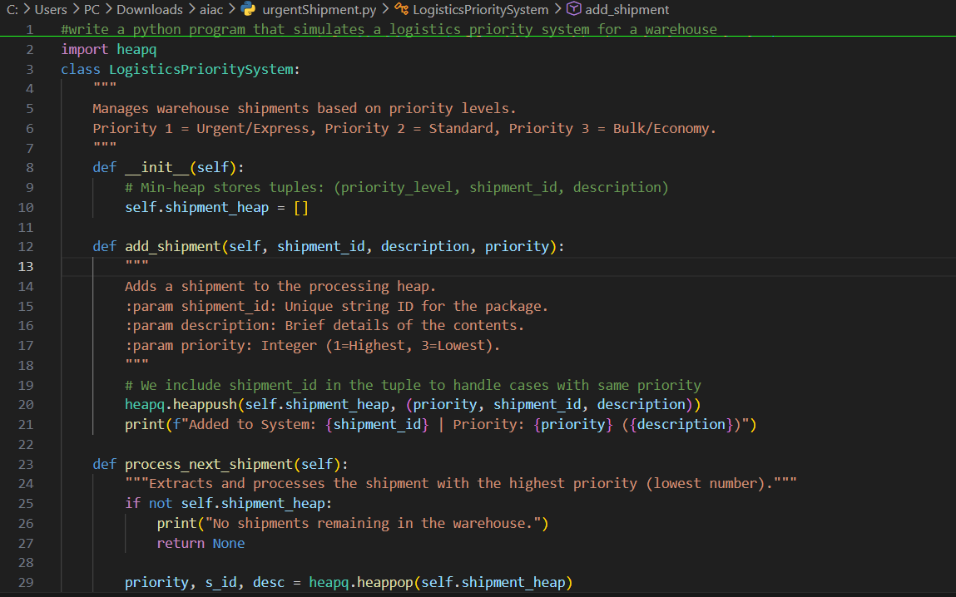
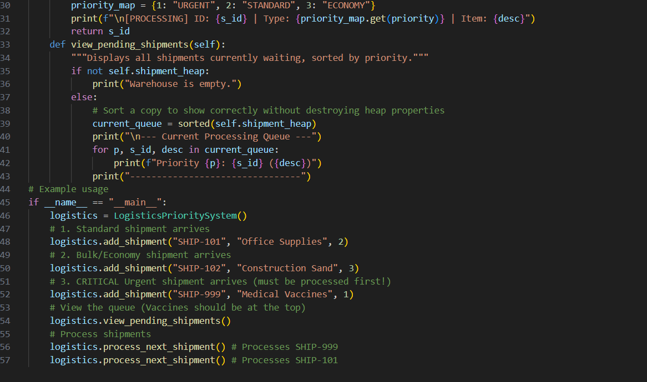

Output 1:
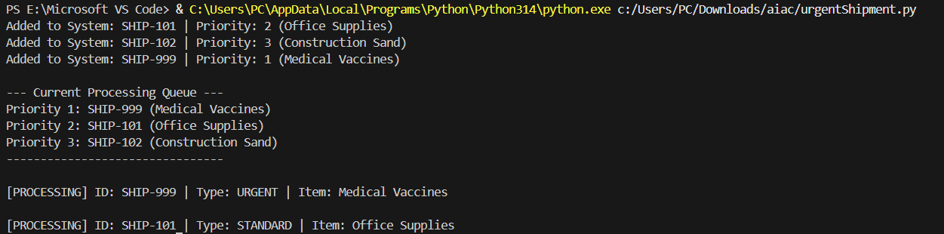
Code 2:
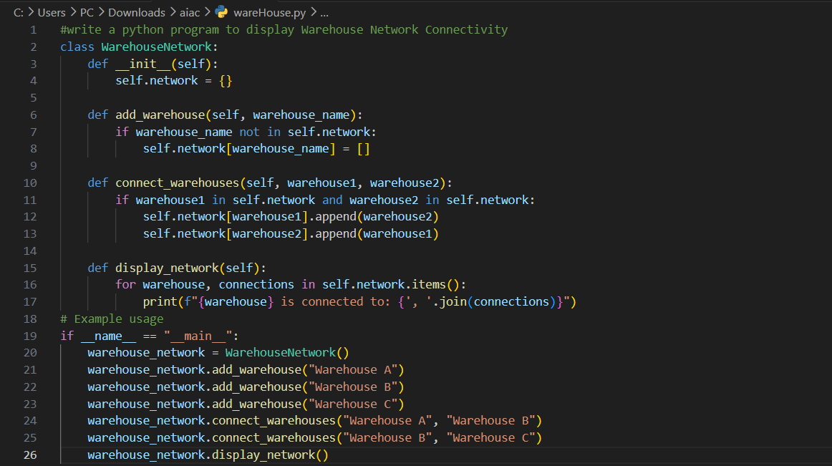
Output 2:
Task Description #14: Smart Banking Management System – Data Structure Challenge
A bank plans to develop a Smart Banking System that includes:
1. Customer Service Token System – Customers are served in order of arrival.
2. Loan Approval Priority Handling – High-value or urgent loans processed first.
3. Account Information Lookup – Fast retrieval of customer details using Account Number.
4. Transaction History Management – Maintain chronological transaction records.
5. ATM Network Connectivity – Represent connections between ATMs across cities.
Student Task:
• For each feature, select the most appropriate data structure from the list below:
o Stack
o Queue
o Priority Queue
o Linked List
o Binary Search Tree (BST)
o Graph
o Hash Table
o Deque
• Justify your choice in 2–3 sentences per feature.
• Implement one selected feature as a working Python program with AI-assisted code generation.
Expected Output:
• A table mapping feature → chosen data structure → justification.
• A functional Python program implementing the chosen feature with comments and docstrings.
Feature | Data Structure
1. Token System | Queue
2. Loan Priority | Priority Queue
3. Account Lookup | Hash Table
4. Transaction History | Linked List
5. ATM Network | Graph
Code 1:
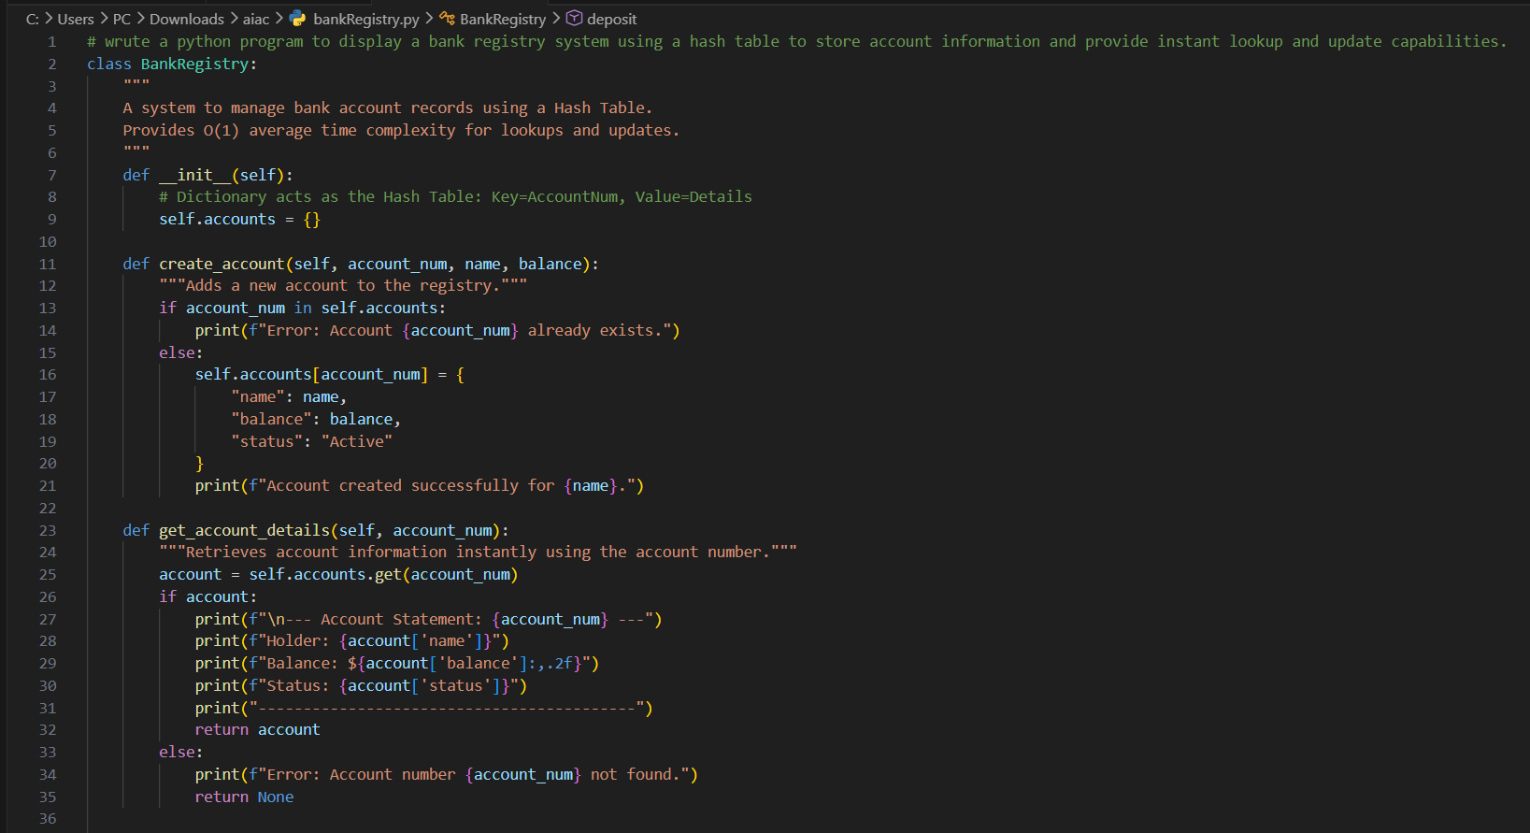
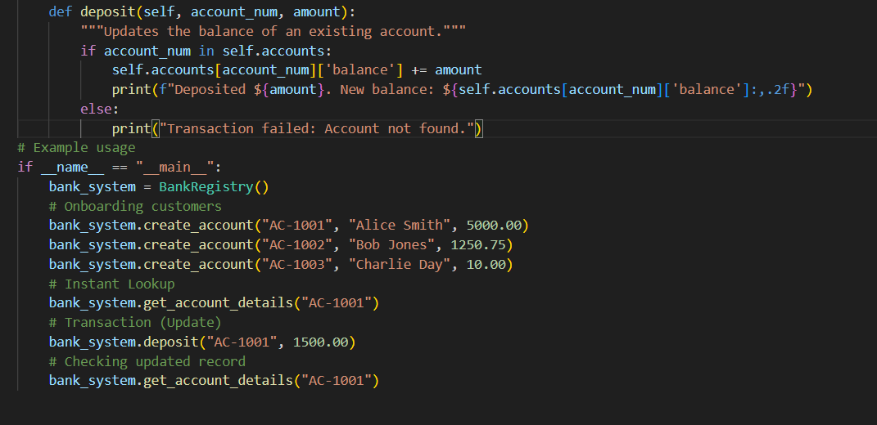
Output 1:
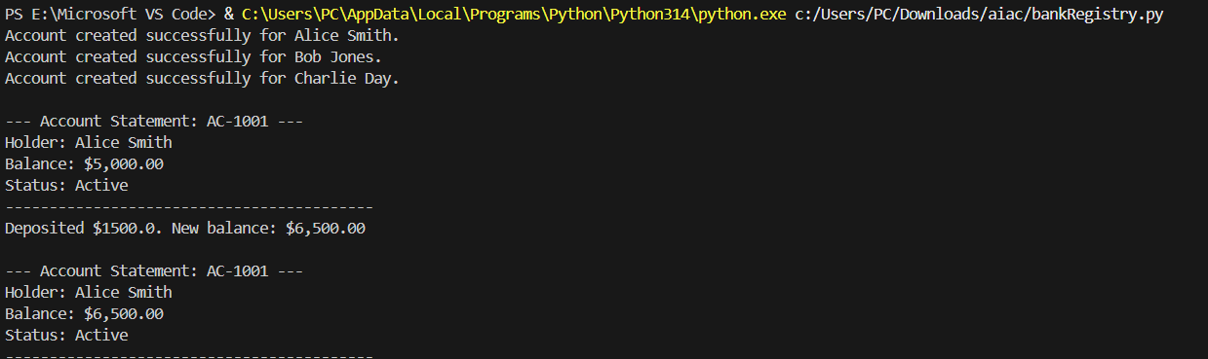
Code 2:
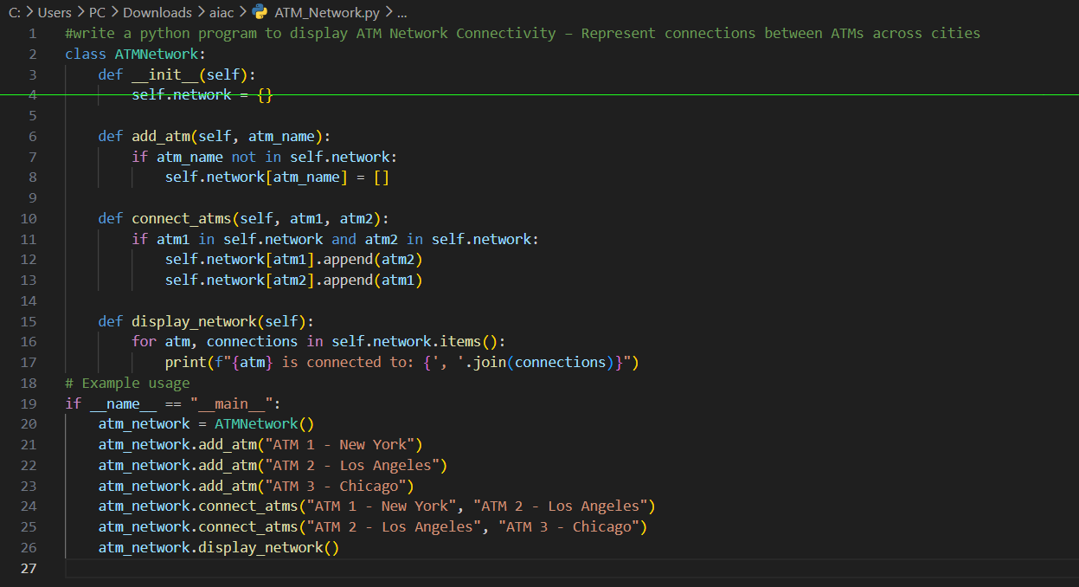
Output 2:
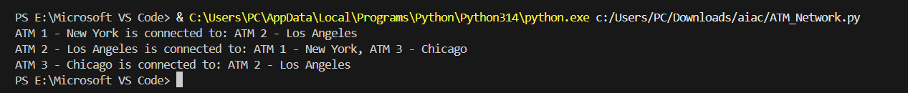
Task Description #15: Online Learning Management System – Data
Structure Selection
An online education platform wants to develop a Learning Management
System that handles:
1. Student Login Authentication – Quick validation of user credentials.
2. Assignment Submission Queue – Submissions processed in order of upload.
3. Top Performer Ranking – Rank students based on scores.
4. Course Prerequisite Structure – Represent subject dependencies.
5. Undo Feature in Online Editor – Reverse recent actions.
Student Task:
• Select the most appropriate data structure for each feature from the given list.
• Justify your selection in 2–3 sentences per feature.
• Implement one selected feature in Python using AI-assisted code generation.
Expected Output:
• Feature → Data Structure → Justification table.
• Functional Python program with proper documentation.
Feature | Data Structure
1. Login Authentication | Hash Table
2. Submission Queue | Queue
3. Top Performer Ranking | Priority Queue
4. Course Prerequisites | Graph
5. Undo Feature | Stack
Code 1:
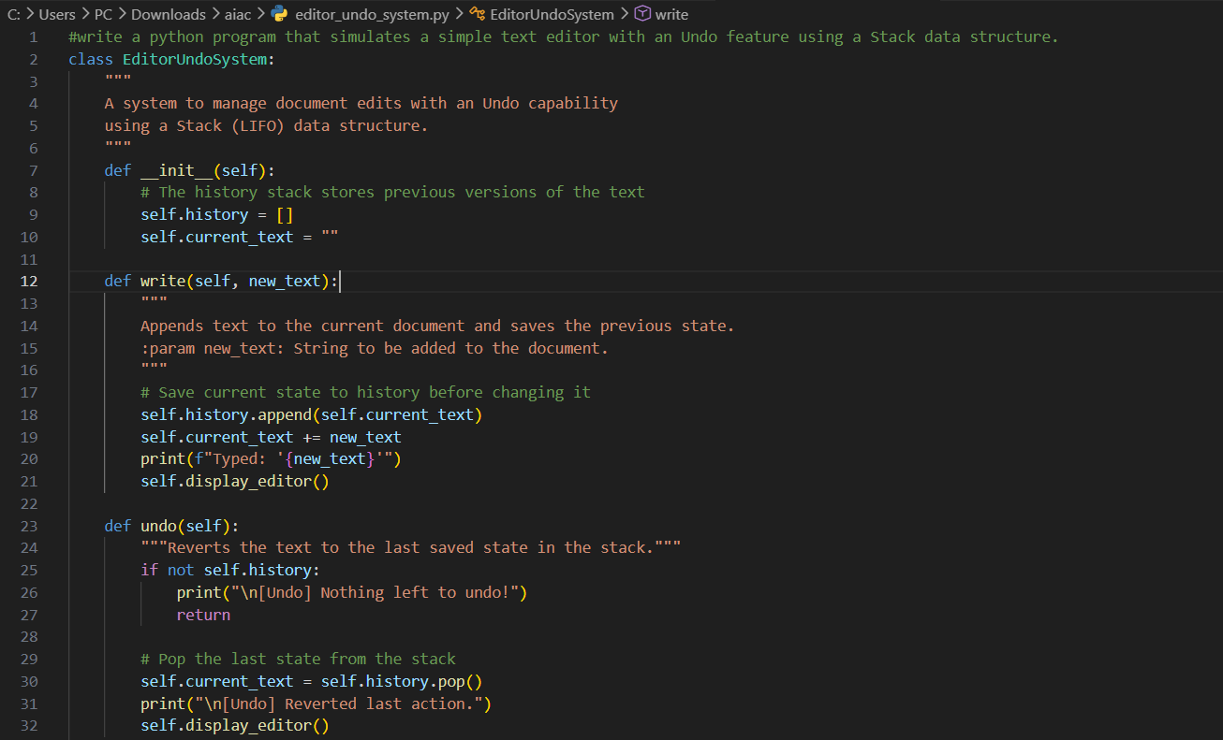
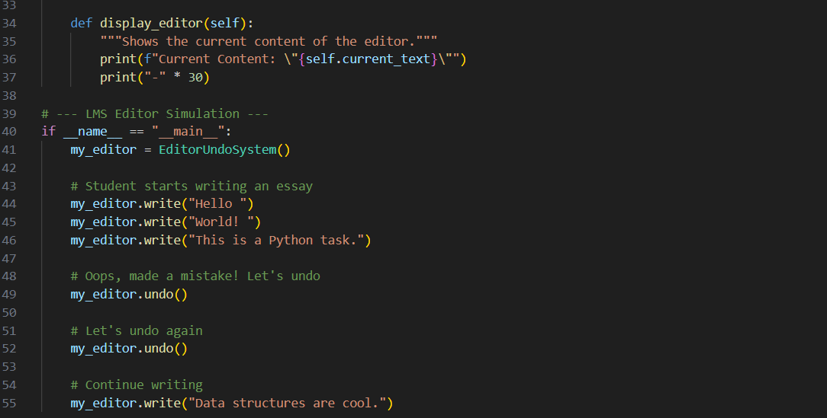
Output 1:
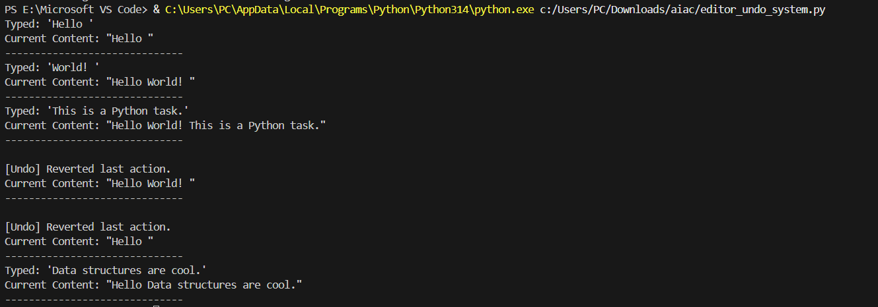

Code 2:
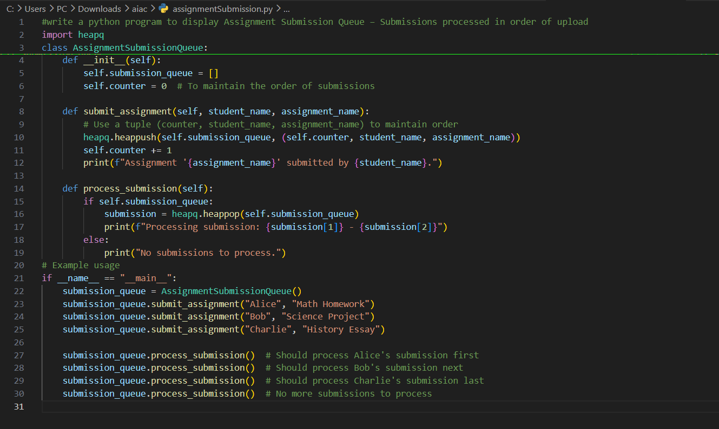
Output 2:
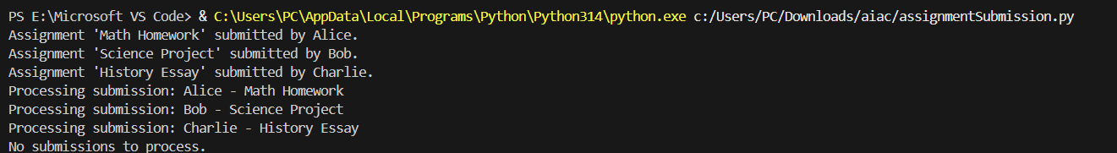
Task Description #16: Smart Airport Management System – Data
Structure Challenge
An airport authority plans to implement:
1. Passenger Check-In Queue – Process passengers in order of arrival.
2. Emergency Landing Priority – Aircraft in emergency get priority.
3. Flight Information Lookup – Fast search using Flight ID.
4. Air Route Connectivity – Airports connected via routes.
5. Boarding Process (Last-In First-Out Cabin Storage) – Overhead luggage management simulation.
Student Task:
• Choose suitable data structures from the provided list.
• Provide 2–3 sentence justification per feature.
• Implement one feature in Python with comments and docstrings using AI assistance.
Expected Output:
• Mapping table.
• Working Python implementation.
Feature | Data Structure
1. Passenger Check-In | Queue
2. Emergency Landing | Priority Queue
3. Flight Lookup | Hash Table
4. Air Route Connectivity | Graph
5. Cabin Storage | Stack
Code 1:
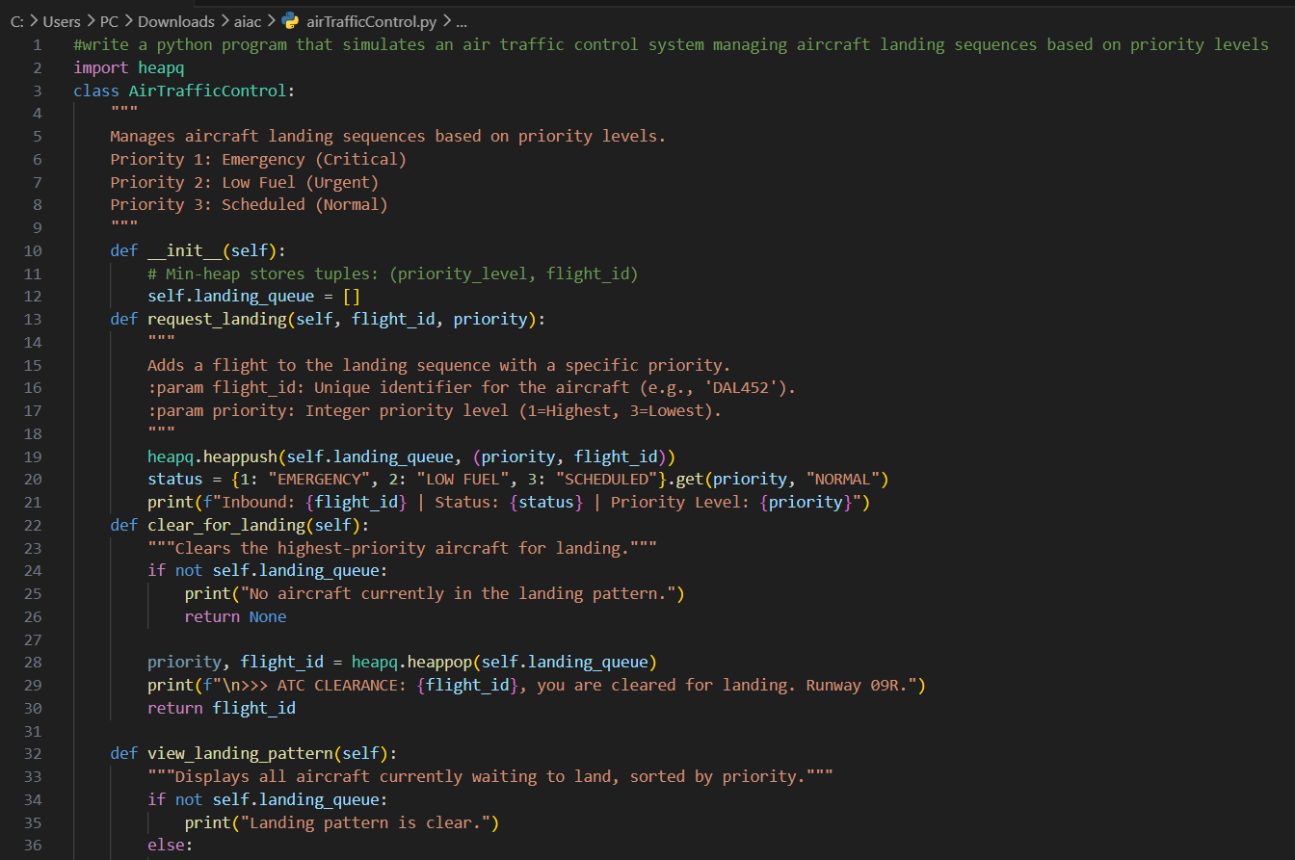
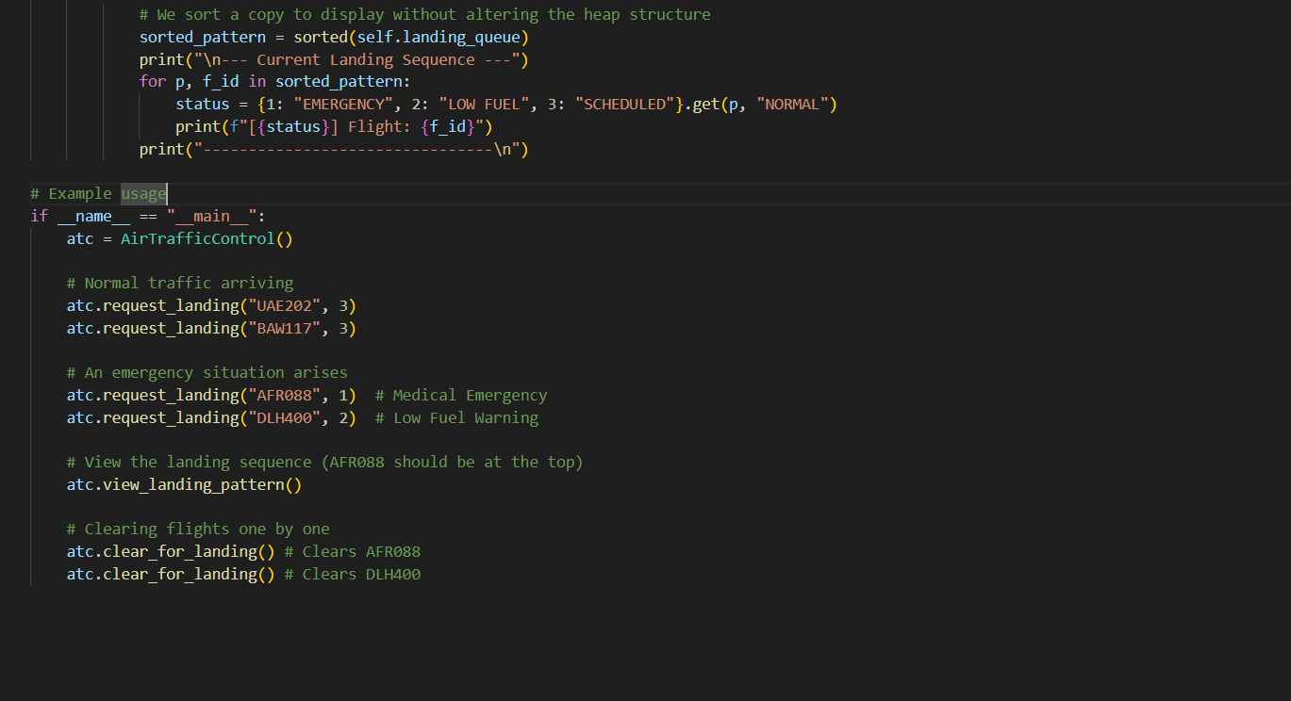
Output 1:
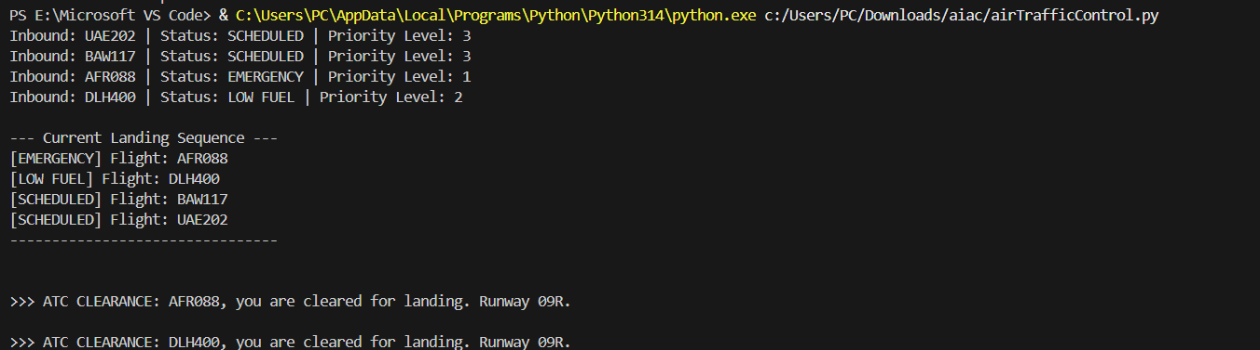
Code 2:
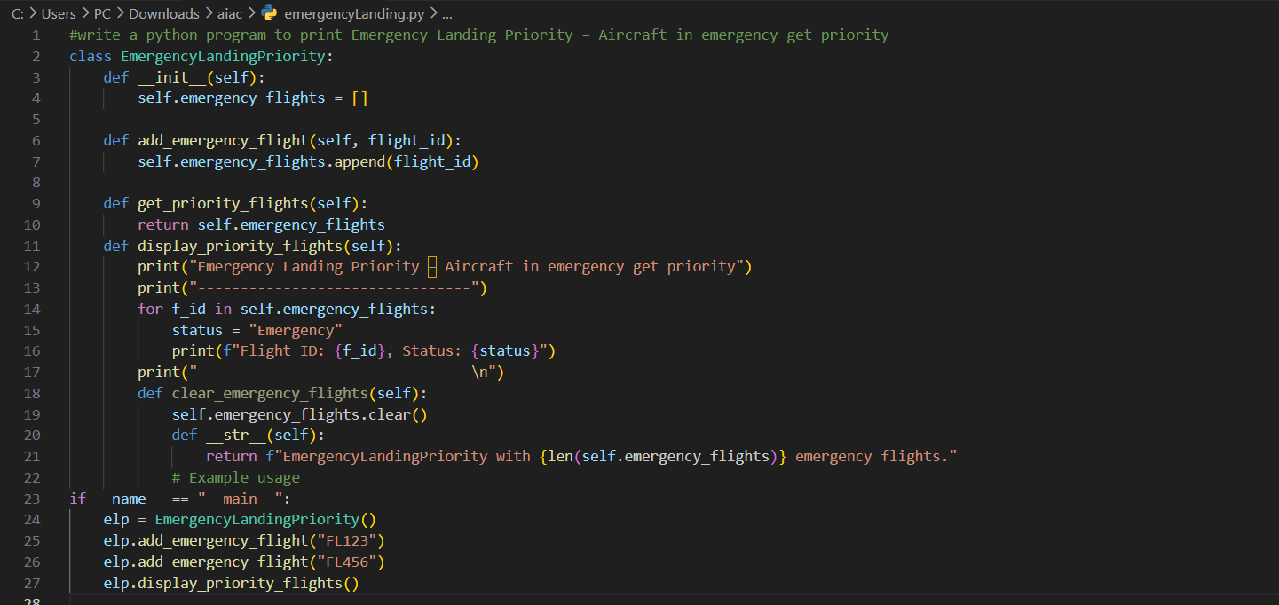
Output 2:
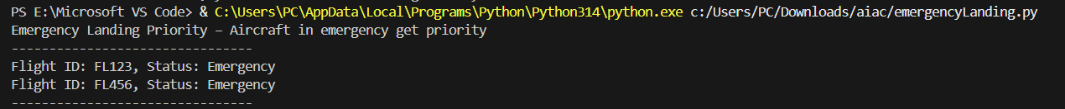

Task Description #17: Smart Social Media Platform – Data Structure Selection
A social media company wants to develop a system that includes:
1. News Feed Generation – Display posts chronologically.
2. Trending Hashtags Tracker – Rank hashtags by usage frequency.
3. User Profile Search – Quick lookup using username.
4. Friend Network Representation – Represent user connections.
5. Message Undo Feature – Allow last sent message to be withdrawn.
Student Task:
• Select appropriate data structures from the list.
• Justify your choices clearly.
• Implement one selected feature as a Python program using AI- assisted code generation.
Expected Output:
• Table mapping features to data structures with justification.
• Working Python code with docstrings and comments.
Feature | Data Structure
1. News Feed | Linked List
2. Trending Hashtags | Priority Queue
3. User Profile Search | Hash Table
4. Friend Network | Graph
5. Message Undo | Stack

Code 1:
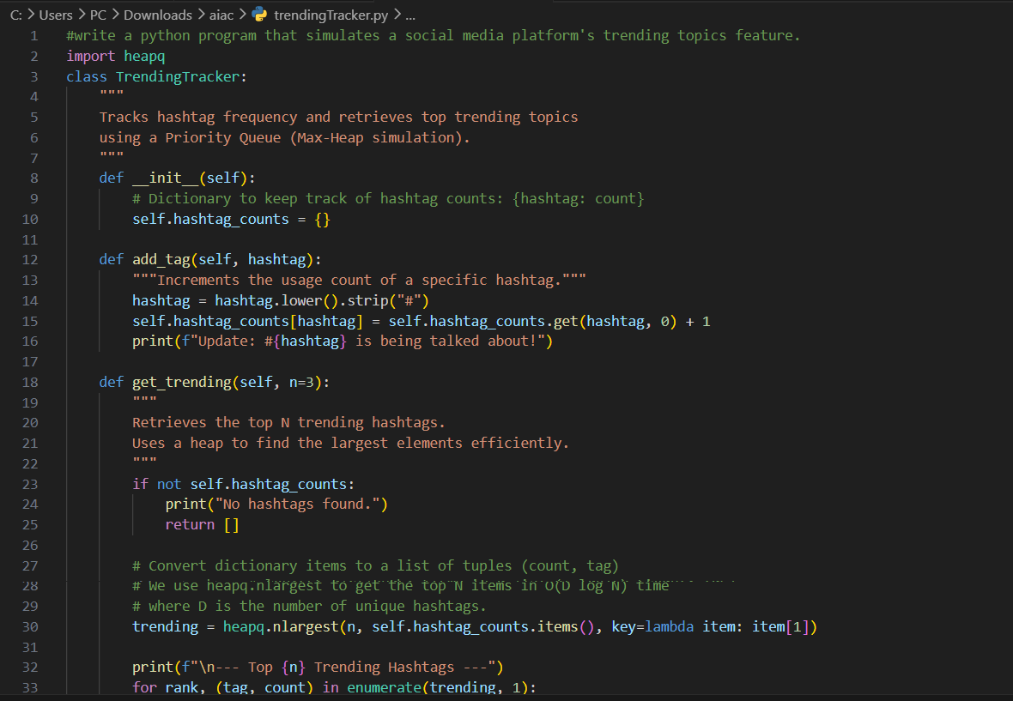
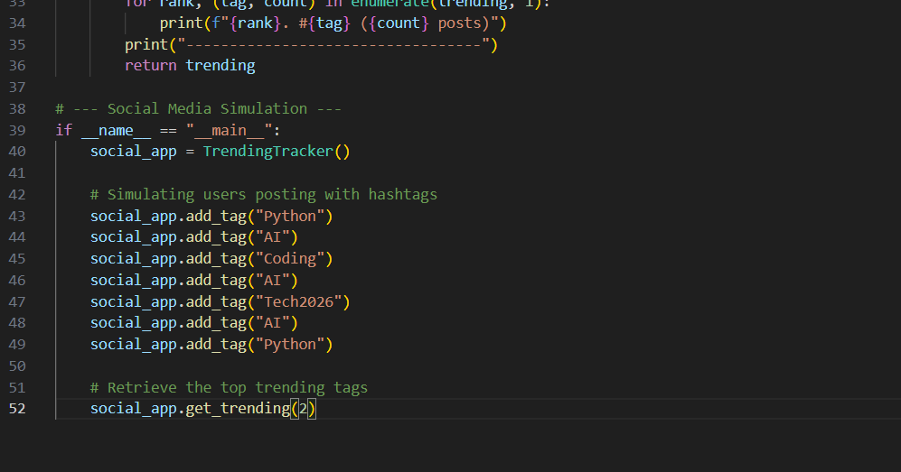
Output 1:
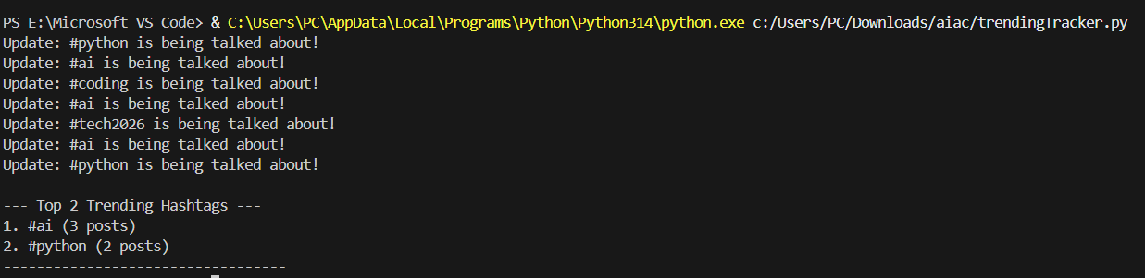

Code 2:
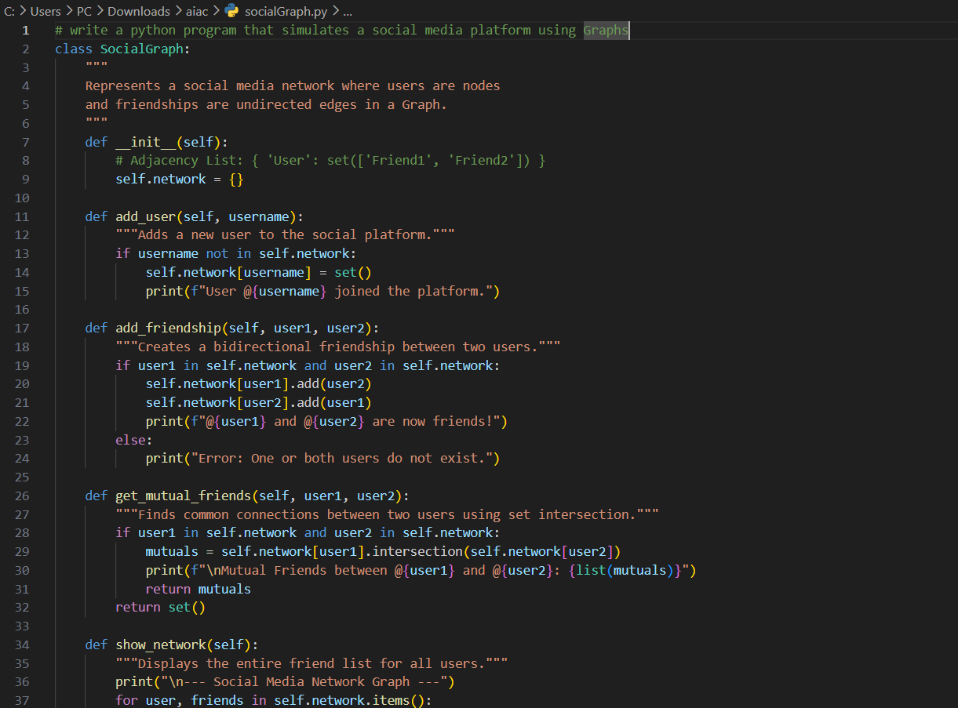
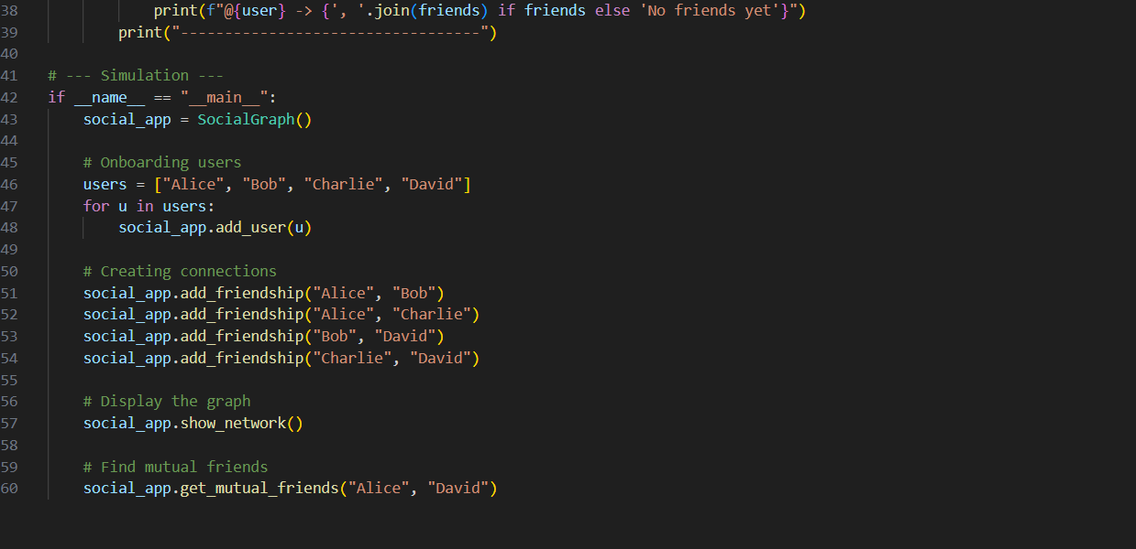
Output 2:
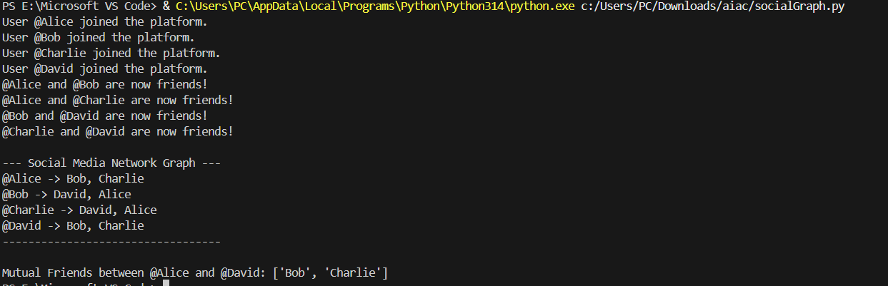
Task #18: Smart University Hostel Management
Scenario:
A university wants to build a hostel management system that manages:
1. Room Allotment
2. Medical Emergency Handling
3. Student Record Retrieval
4. Hostel Block Connectivity
5. Visitor Entry Log
Student Task
• For each feature, select the most appropriate data structure from the list below:
o Stack
o Queue
o Priority Queue
o Linked List
o Binary Search Tree (BST)
o Graph
o Hash Table
o Deque
• Justify your choice in 2–3 sentences per feature.
• Implement one selected feature as a working Python program with AI-assisted code generation.
Expected Output:
• A table mapping feature → chosen data structure → justification.
• A functional Python program implementing the chosen feature with comments and docstrings.
Feature | Data Structure
1. Room Allotment | Queue
2. Medical Emergency | Priority Queue
3. Student Records | Hash Table
4. Block Connectivity | Graph
5. Visitor Entry Log | Linked List
Code 1:
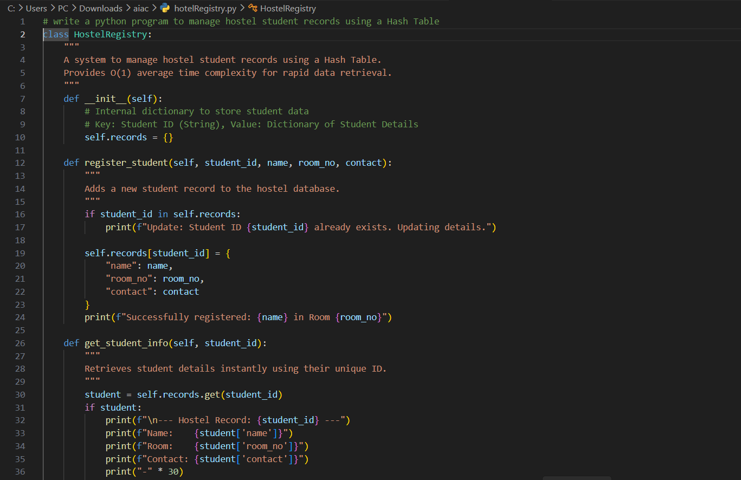
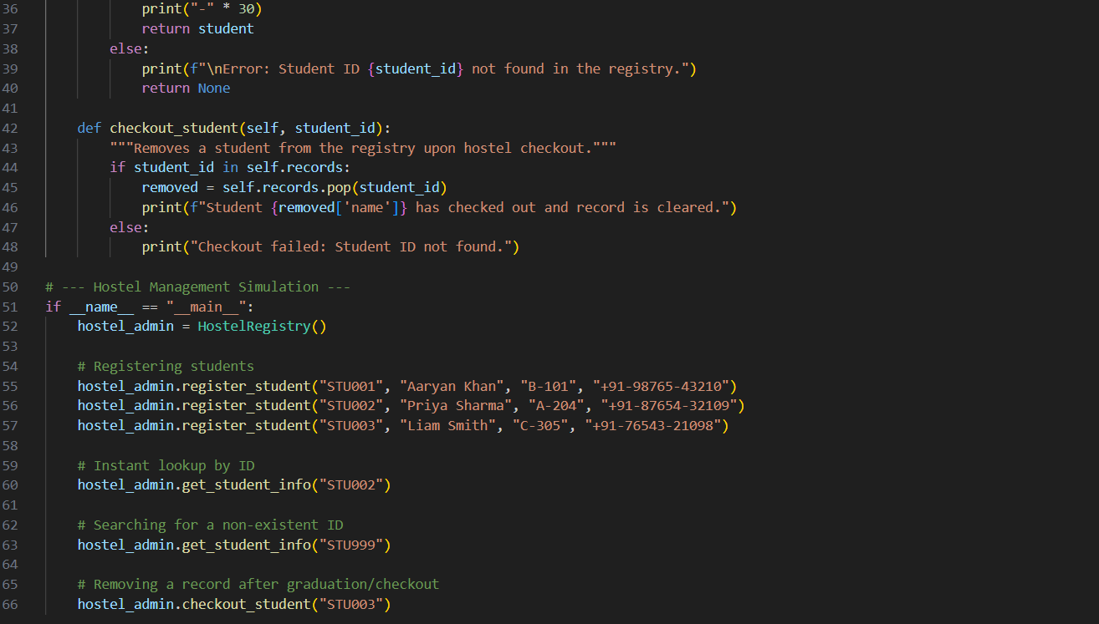
Output 1:
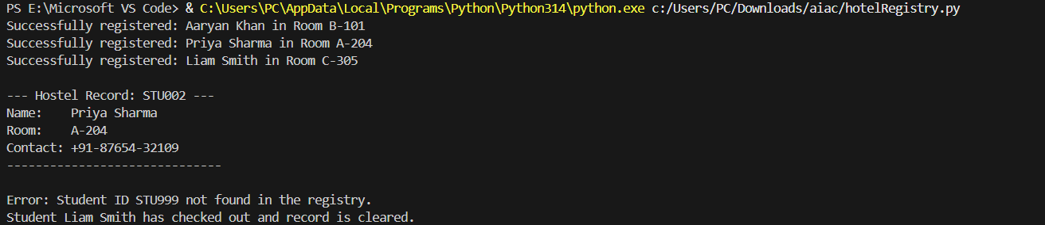
Code 2:
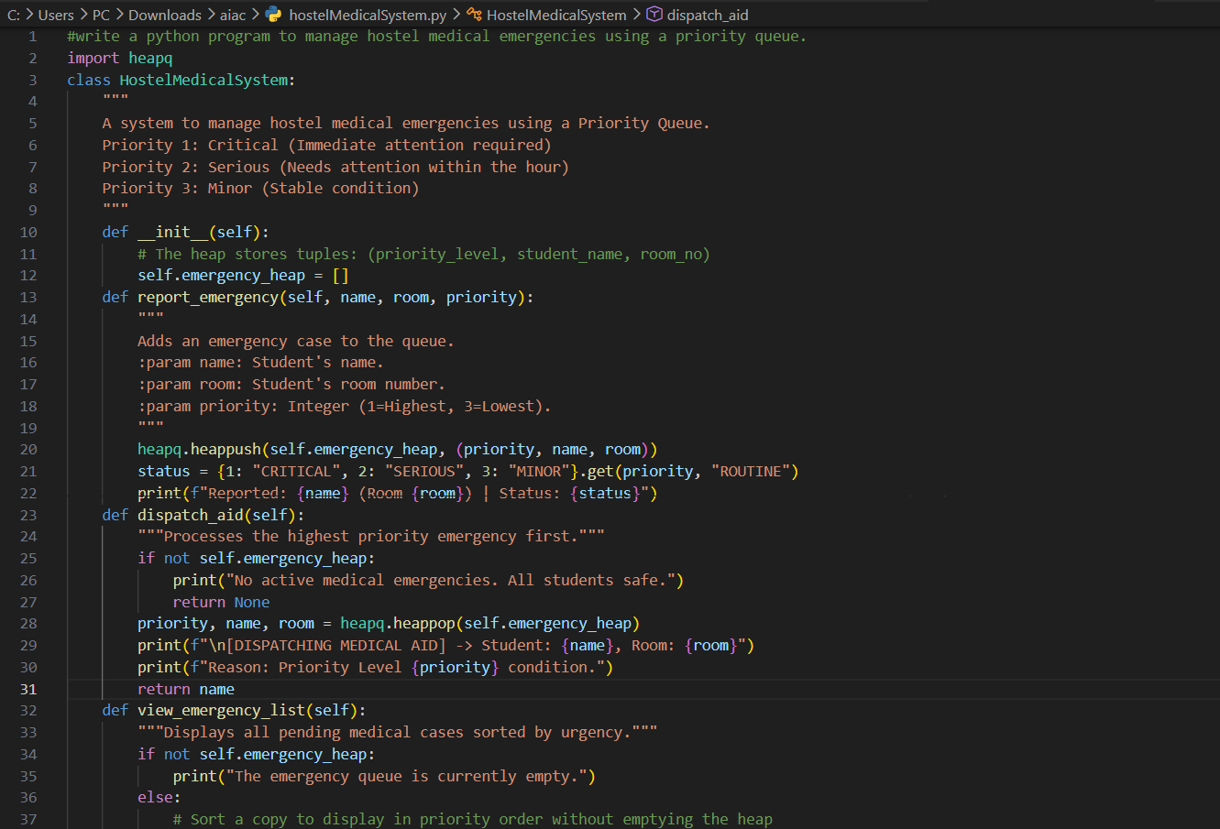
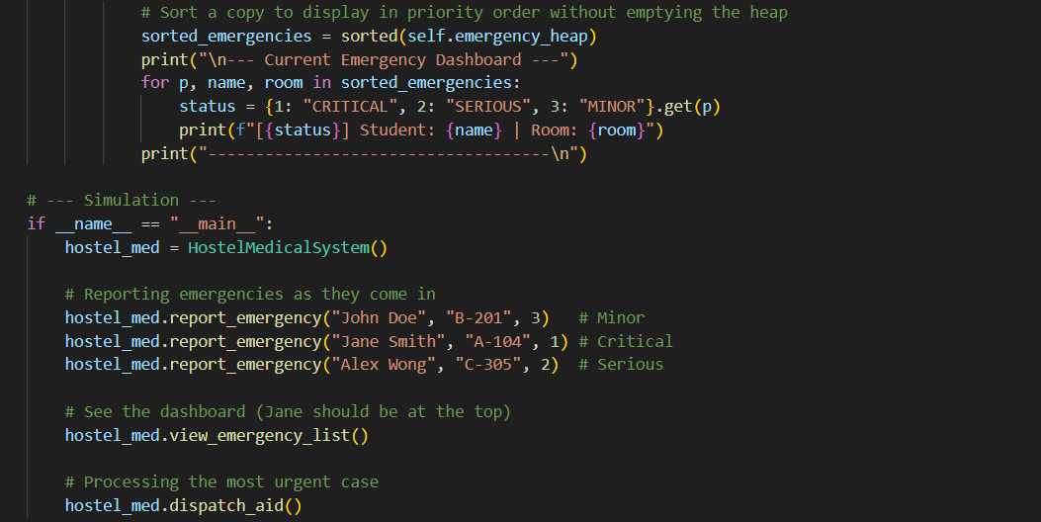

Output 2:
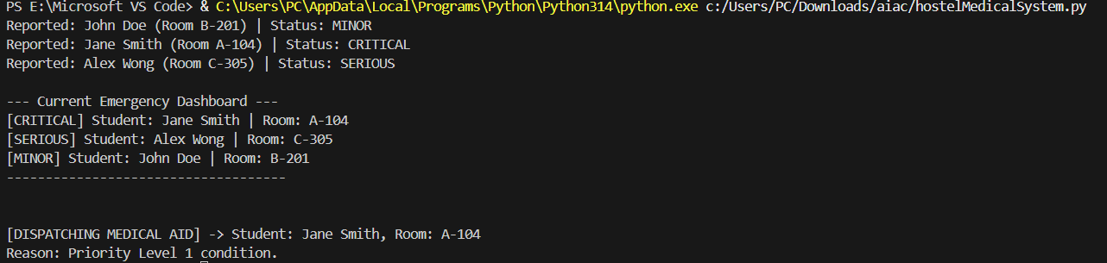
Task #19: Smart Electricity Distribution System
Scenario:
An electricity board plans to develop a system that includes:
1. Complaint Handling
2. Fault Priority Handling
3. Consumer Record Lookup
4. Power Grid Connectivity
5. Meter Reading History Tracking
Student Task
• For each feature, select the most appropriate data structure from
the list below:
o Stack
o Queue
o Priority Queue
o Linked List
o Binary Search Tree (BST)
o Graph
o Hash Table
o Deque
• Justify your choice in 2–3 sentences per feature.
• Implement one selected feature as a working Python program with
AI-assisted code generation.
Expected Output:
• A table mapping feature → chosen data structure → justification.
• A functional Python program implementing the chosen feature
with comments and docstrings.
Feature | Data Structure
1. Complaint Handling | Queue
2. Fault Priority | Priority Queue
3. Consumer Lookup | Hash Table
4. Power Grid | Graph
5. Reading History | Linked List

Code 1:
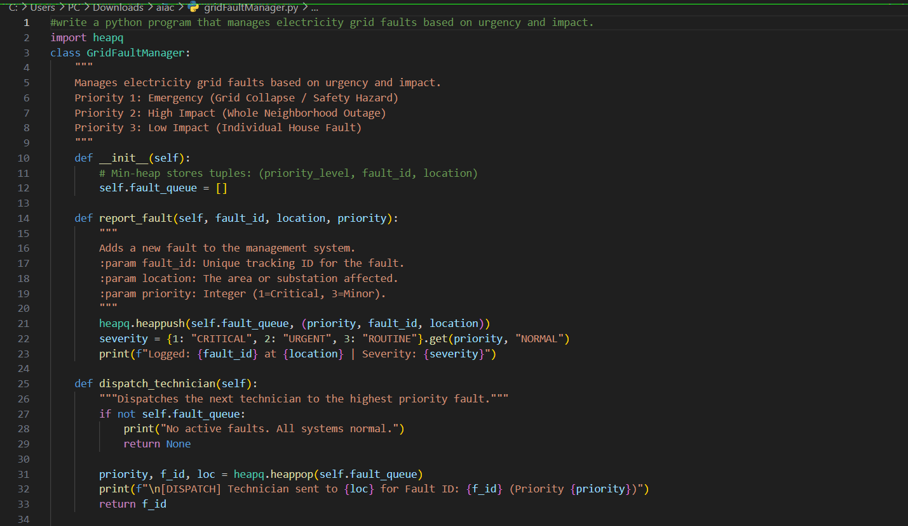
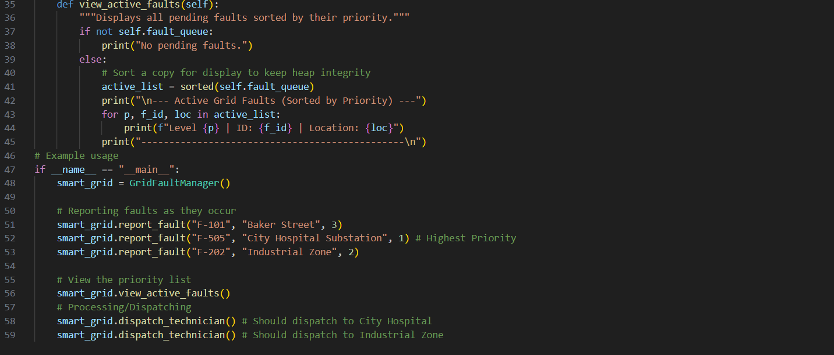
Output 1:
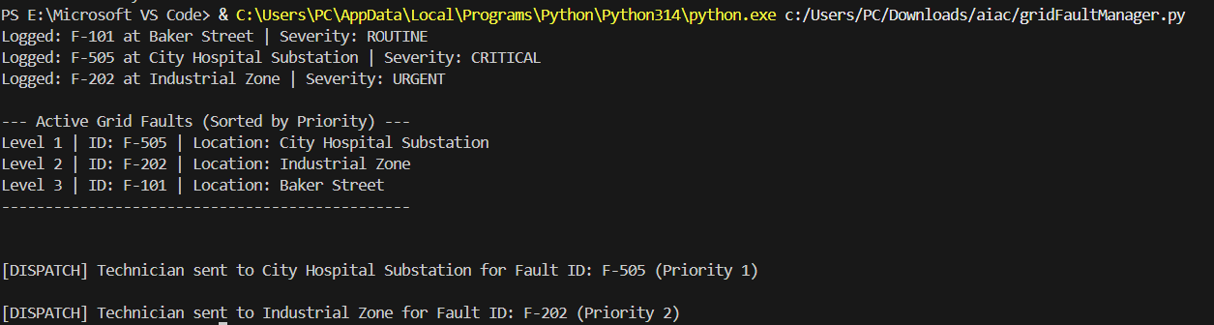
Code 2:
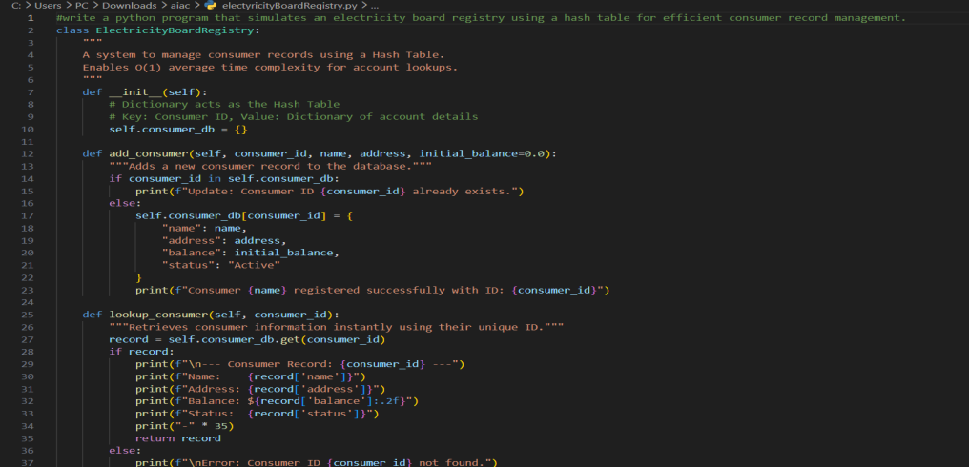
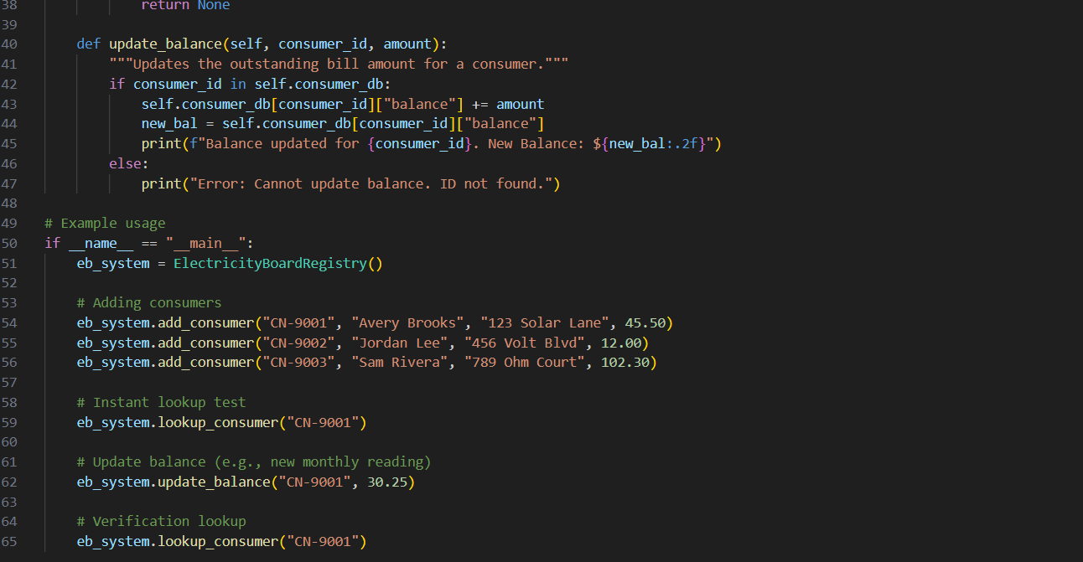
Output 2:
